Login to HUE and check file browser

Getting issue in file browser

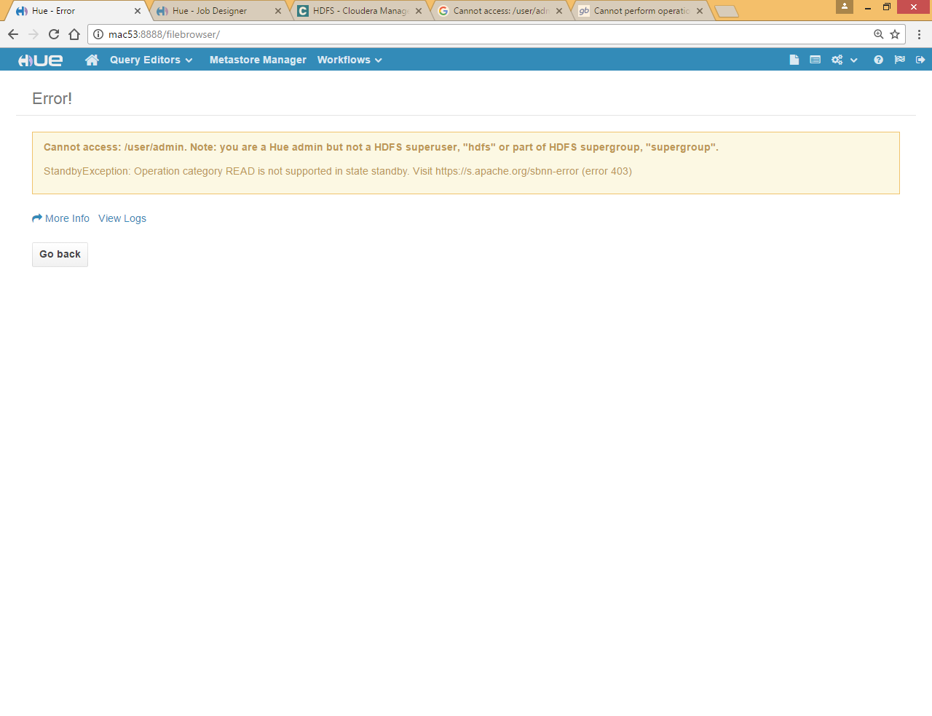

This issue occurs when we enable HA on namenode , HUE is not pointing to Active name node instead pointing to stand by name node

Go to Cloudera-manager >> hue>>configuration and change Namenode

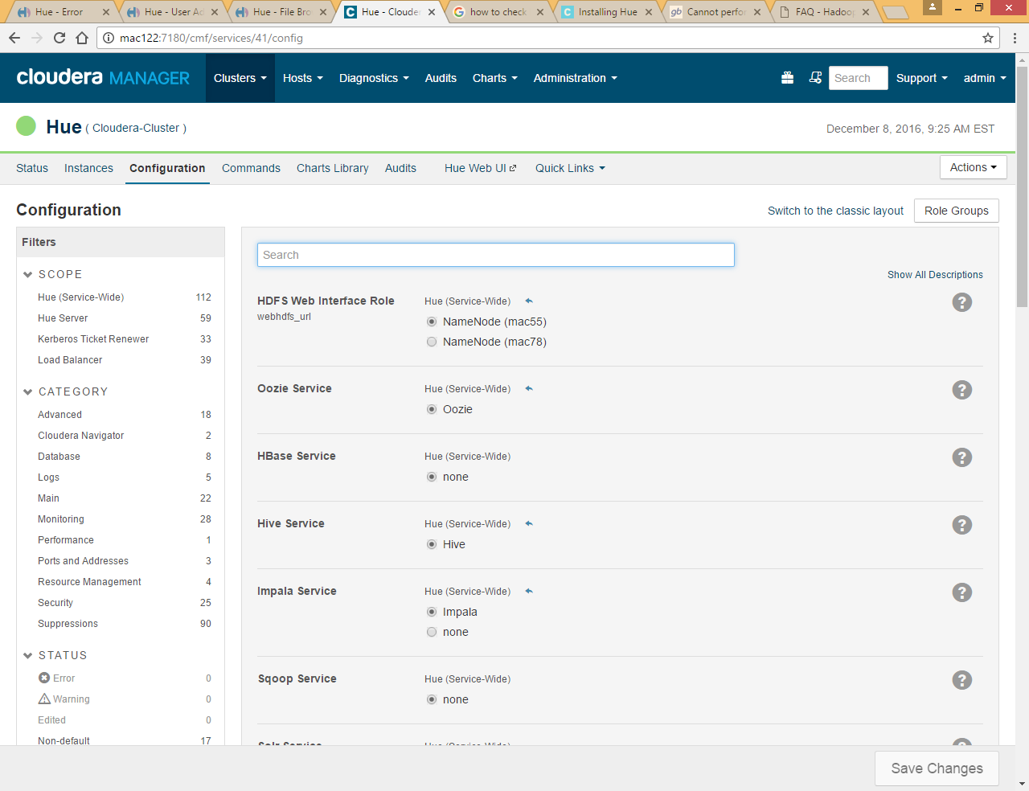

Restart hue

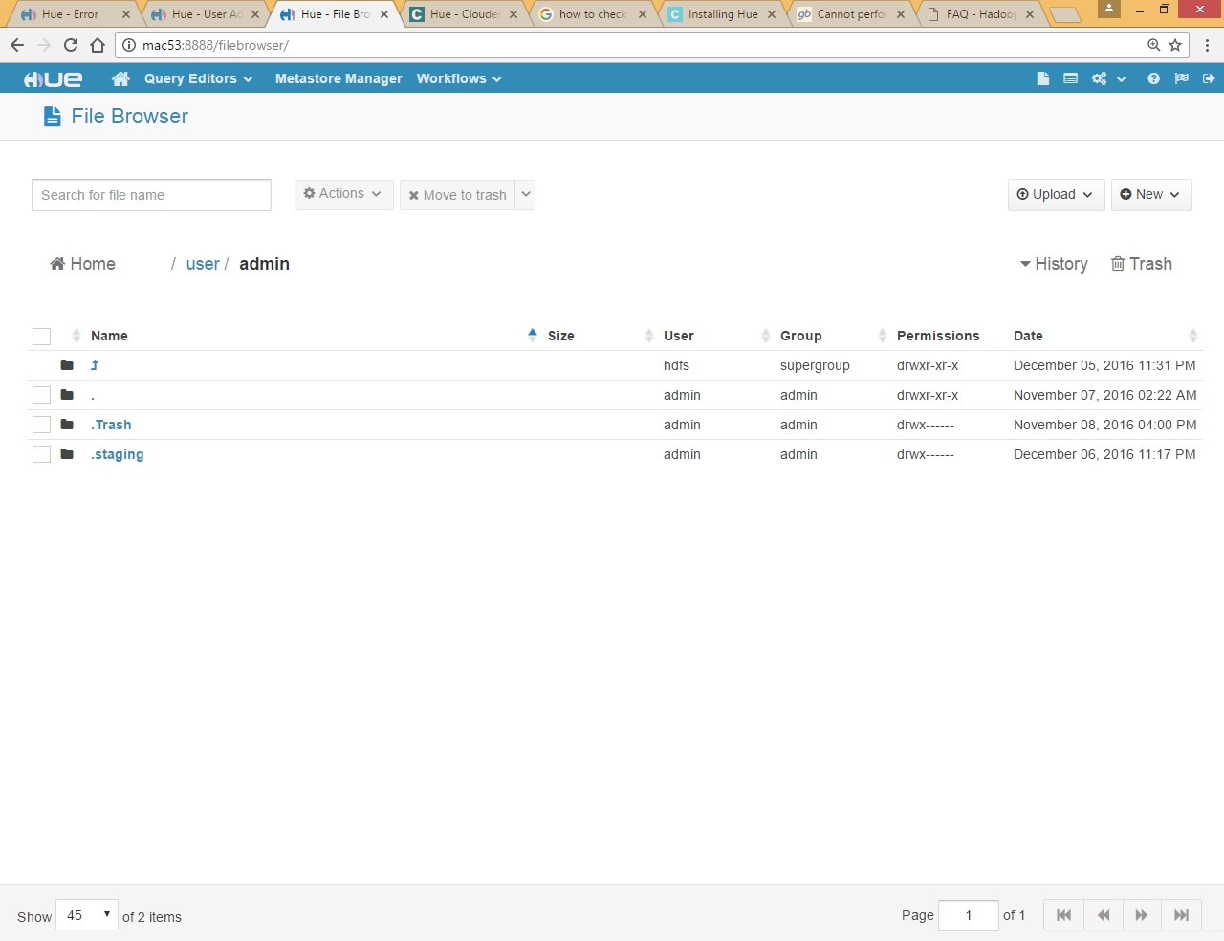

Now you can access file browser

# Create workflow by Job Designer

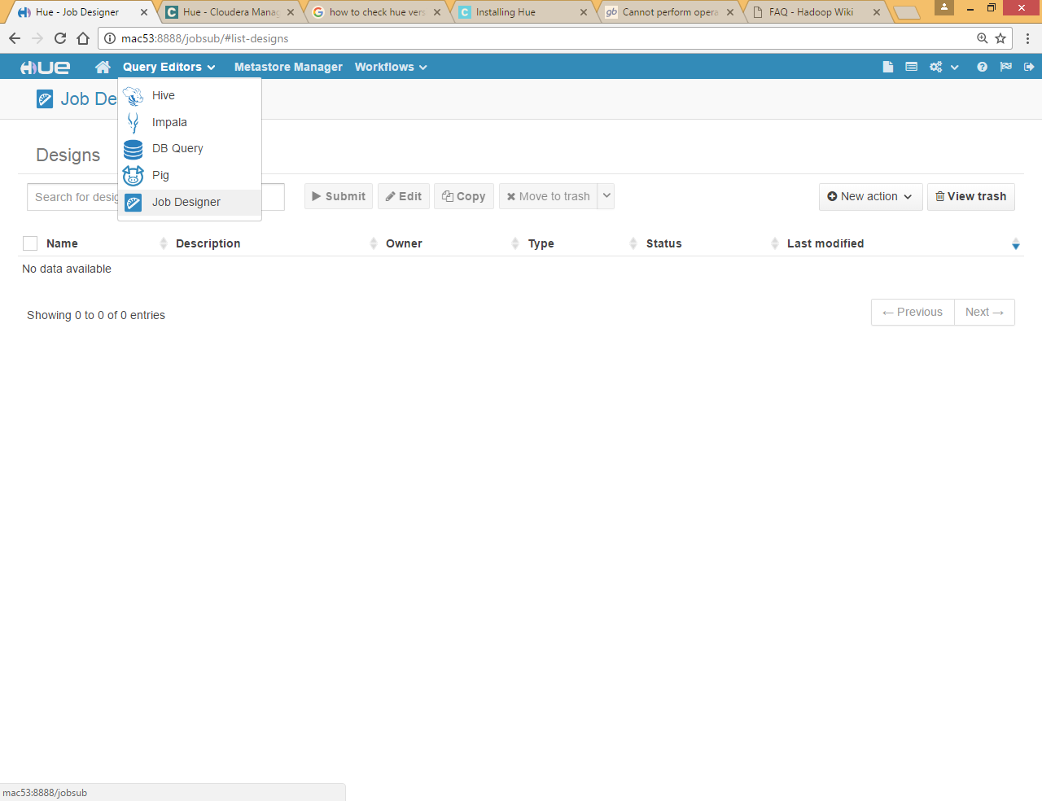

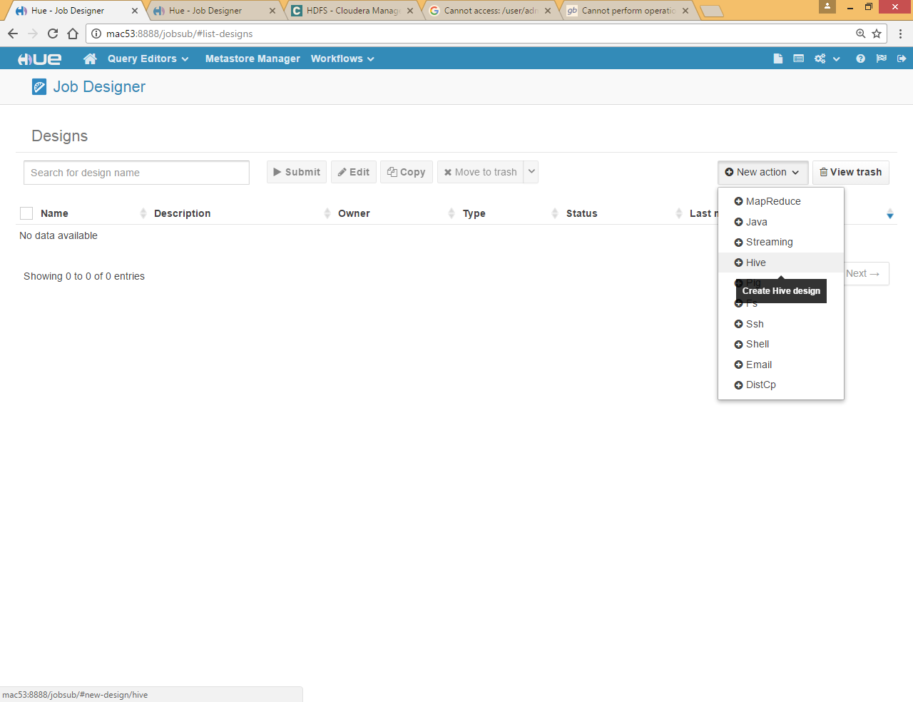

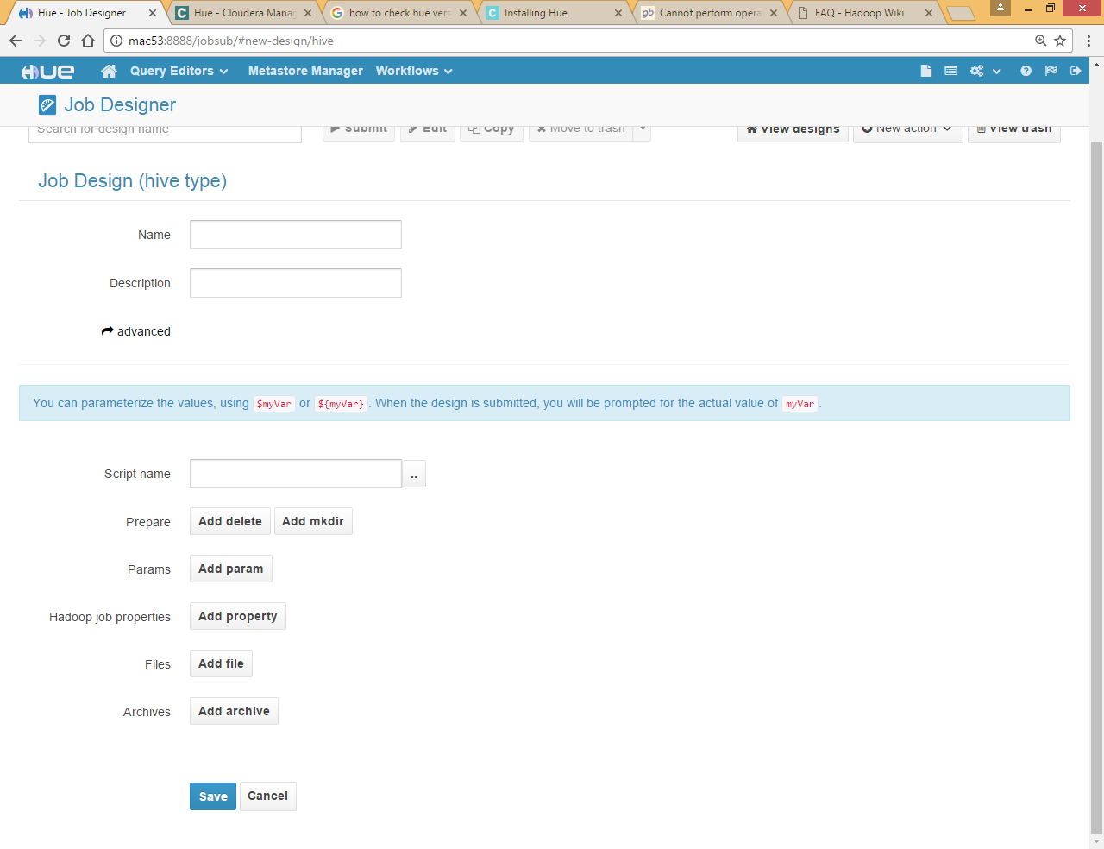

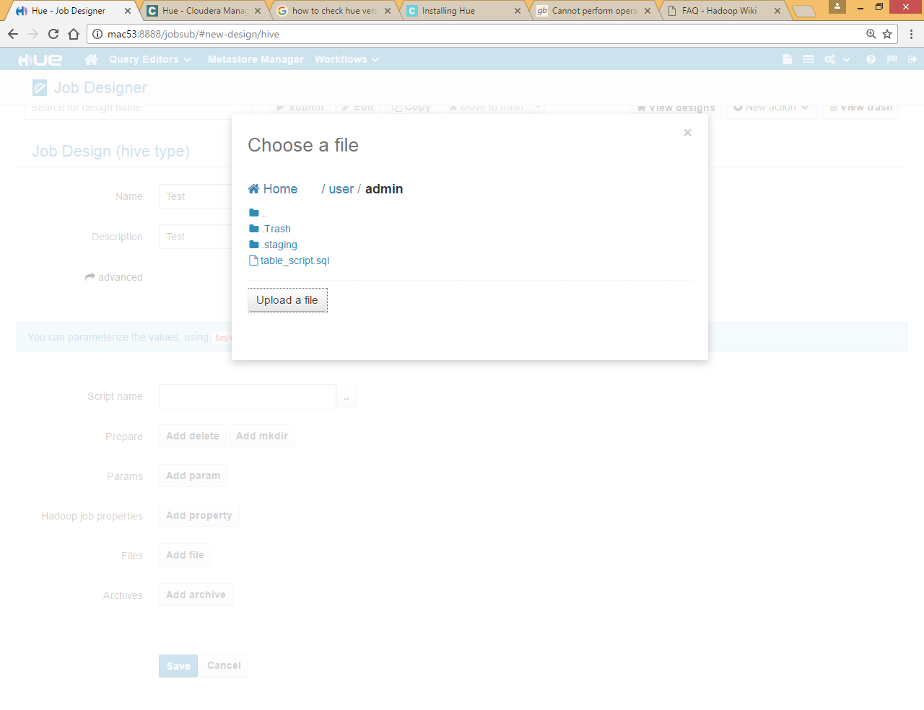

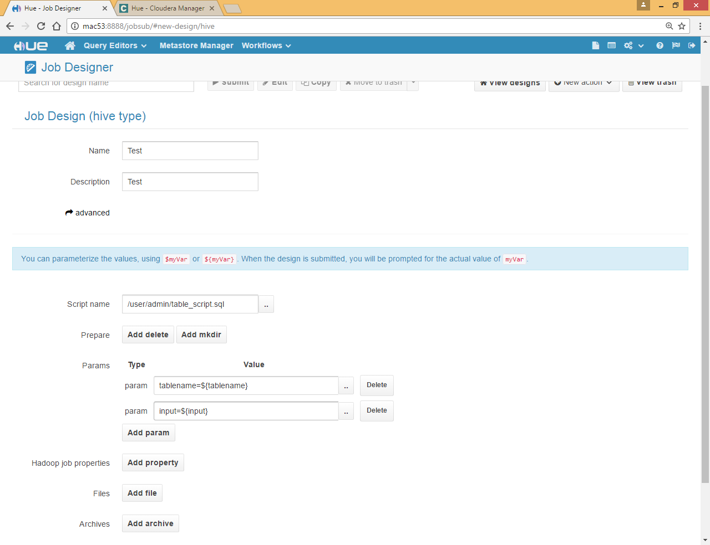

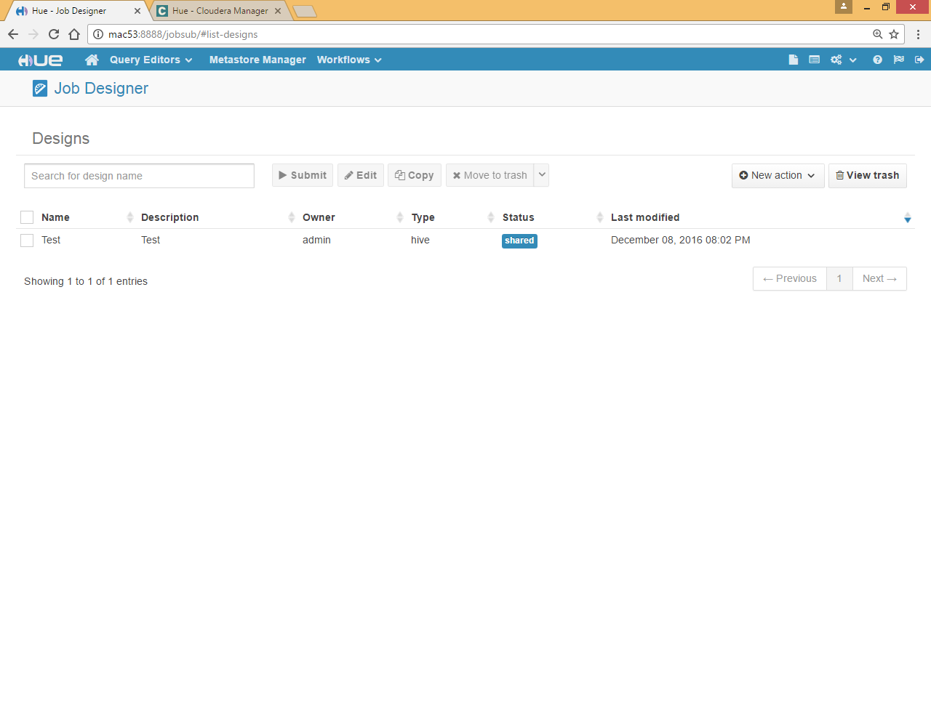

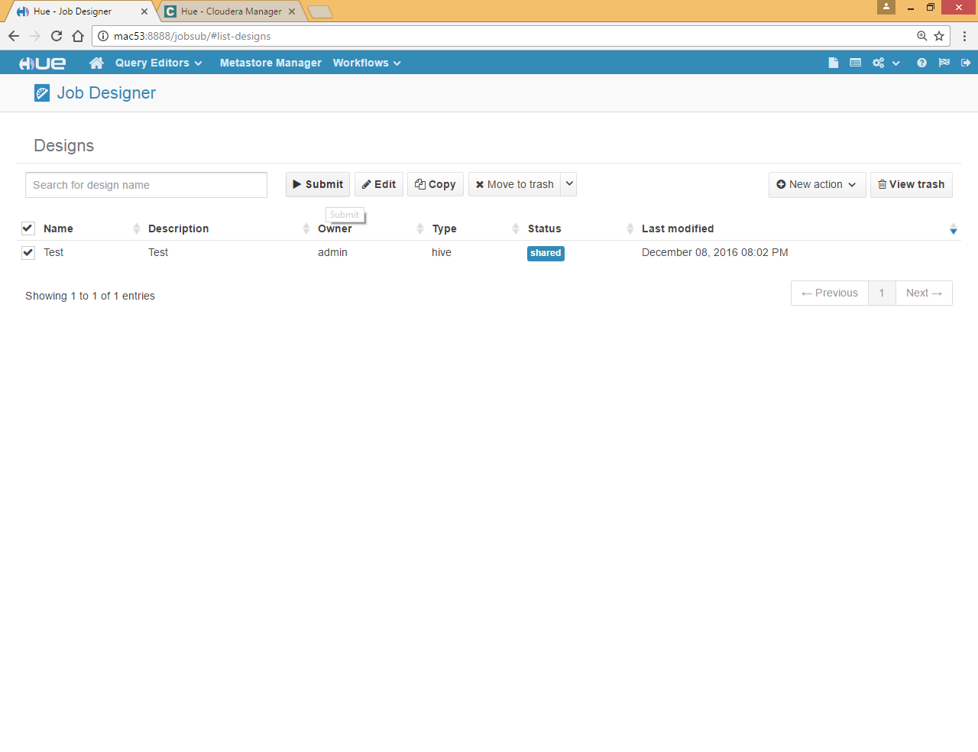

Select and submit

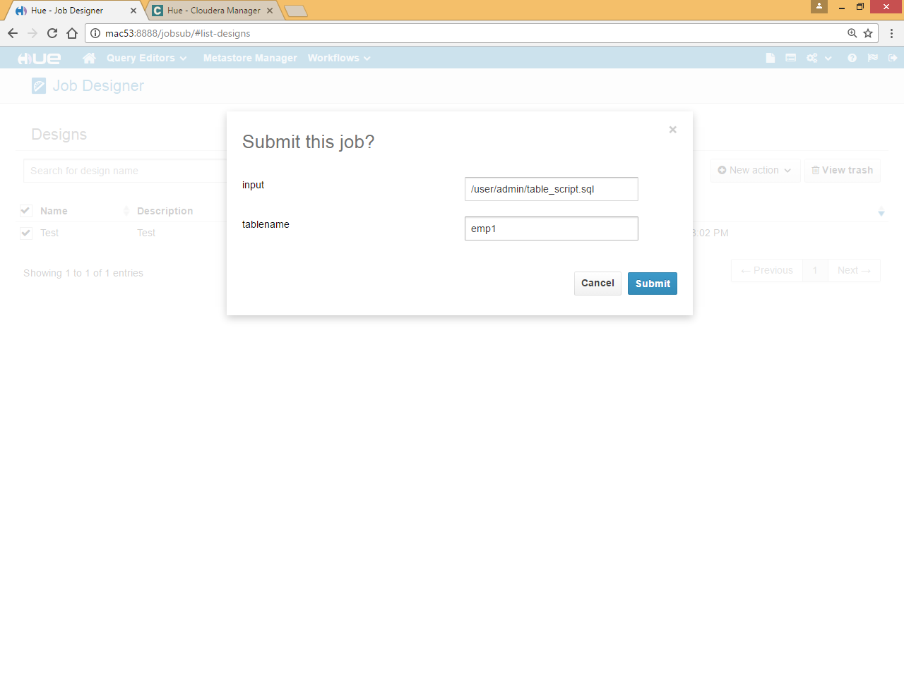

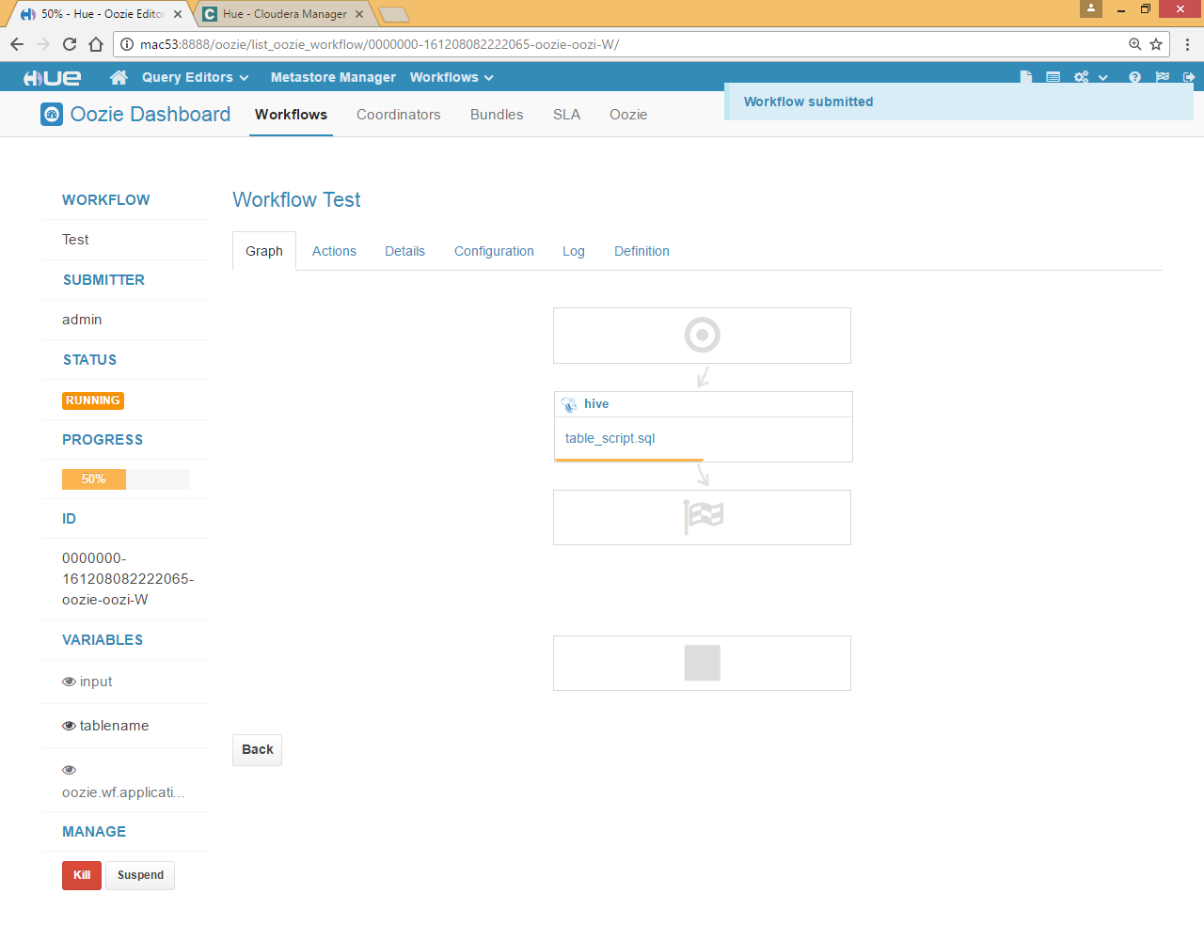

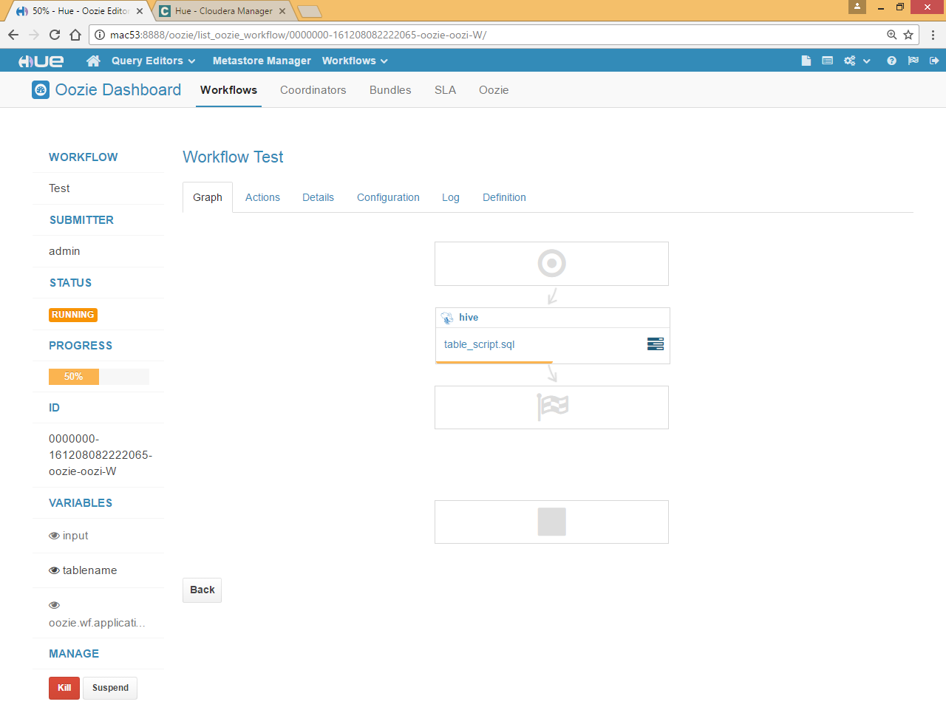

Click on icon log

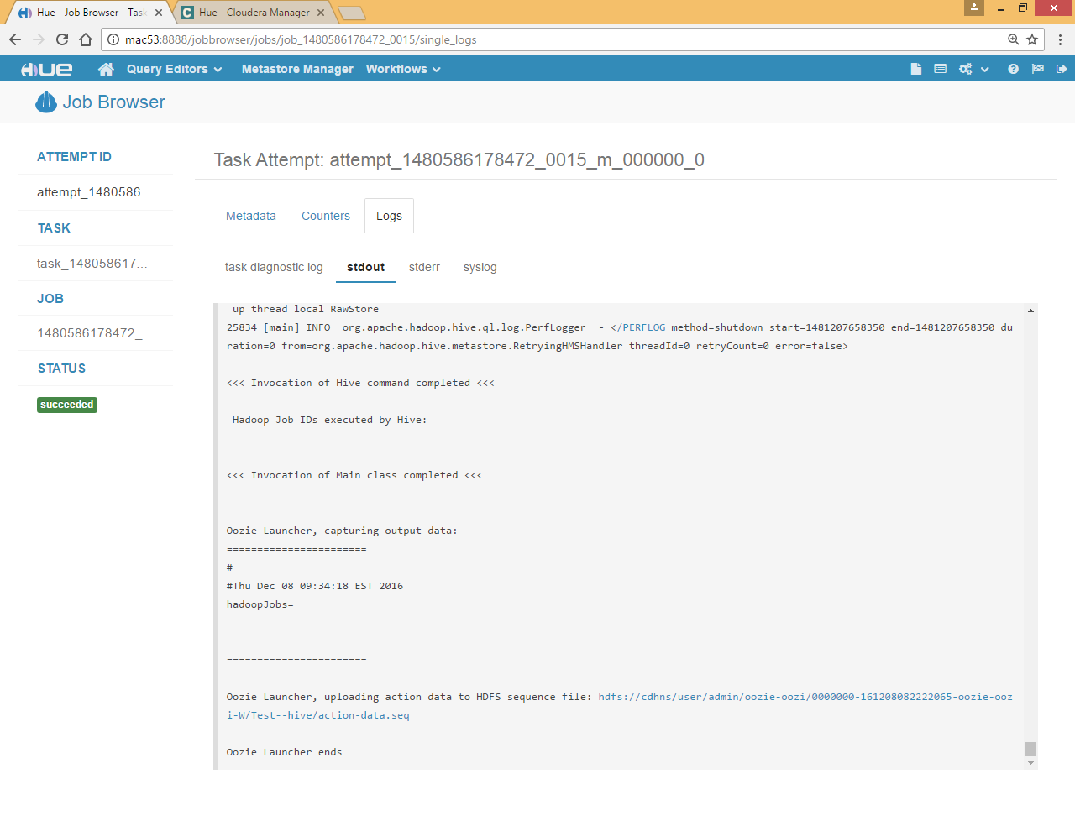

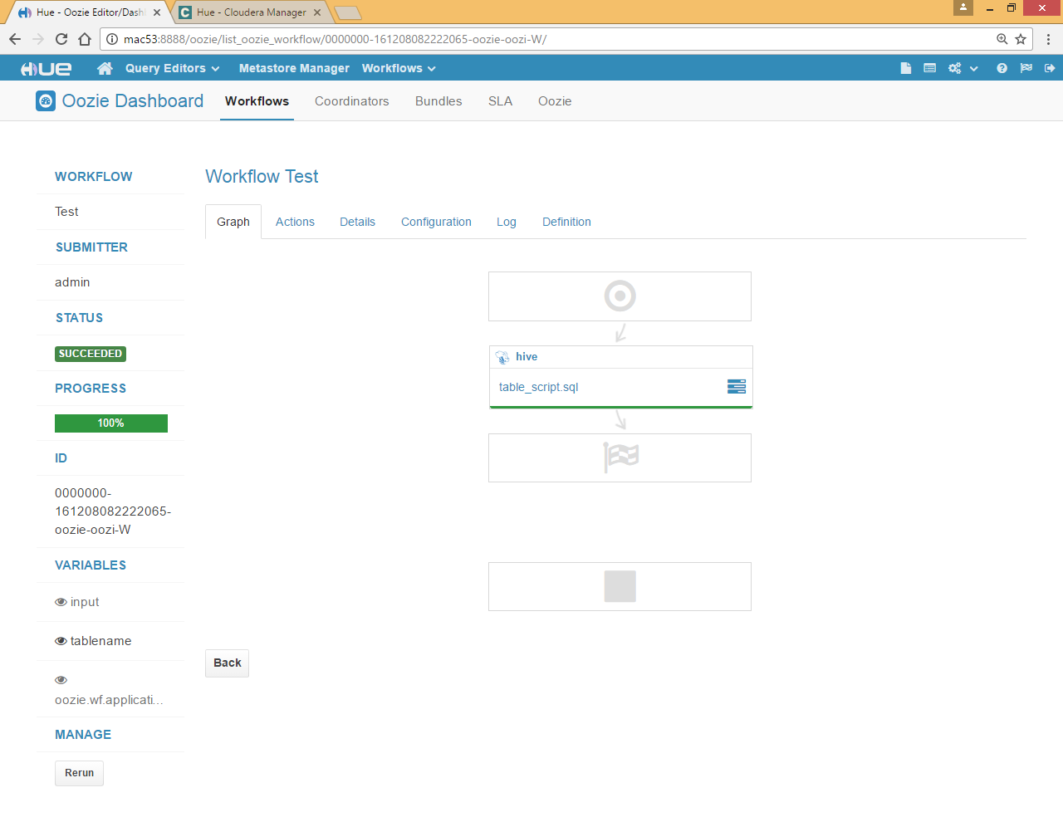

# Oozie workflow by drag and drop

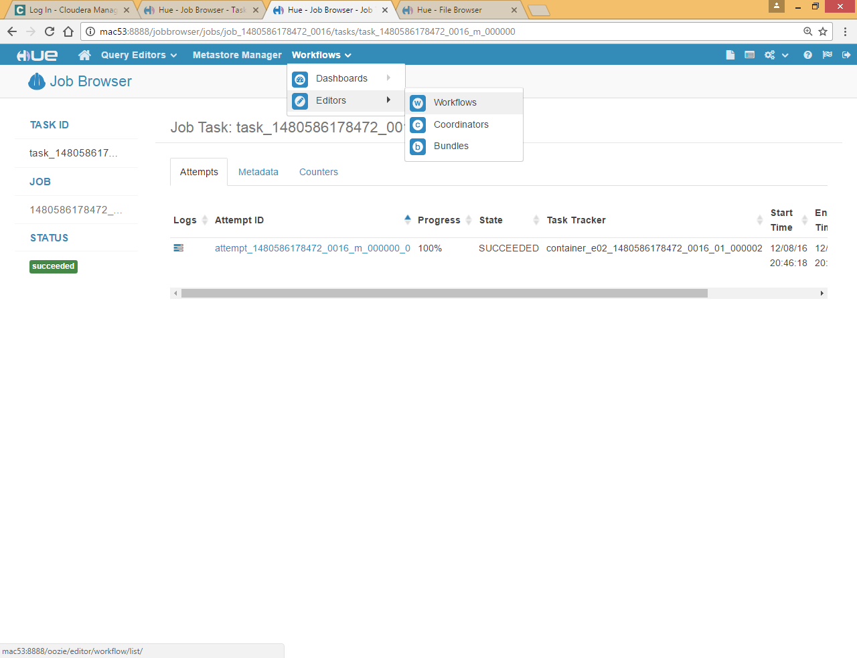

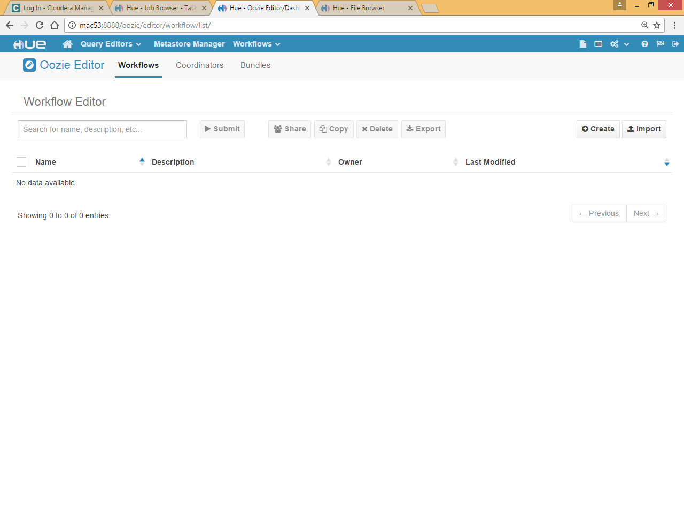

Click Create

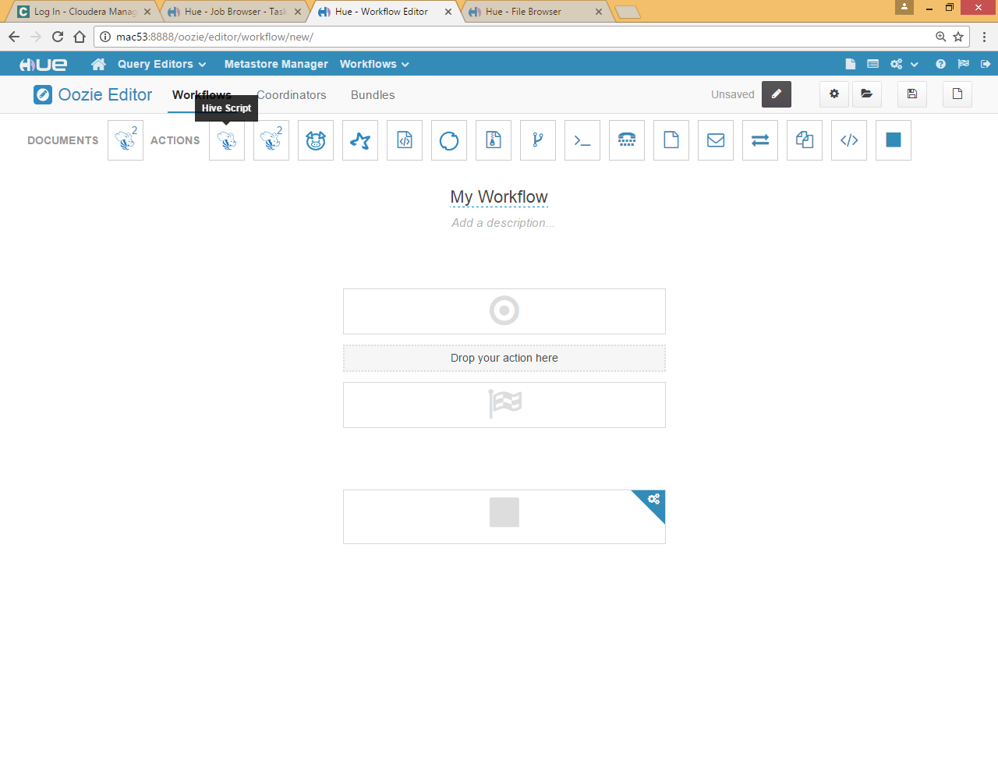

Drag hive script and drop in workflow

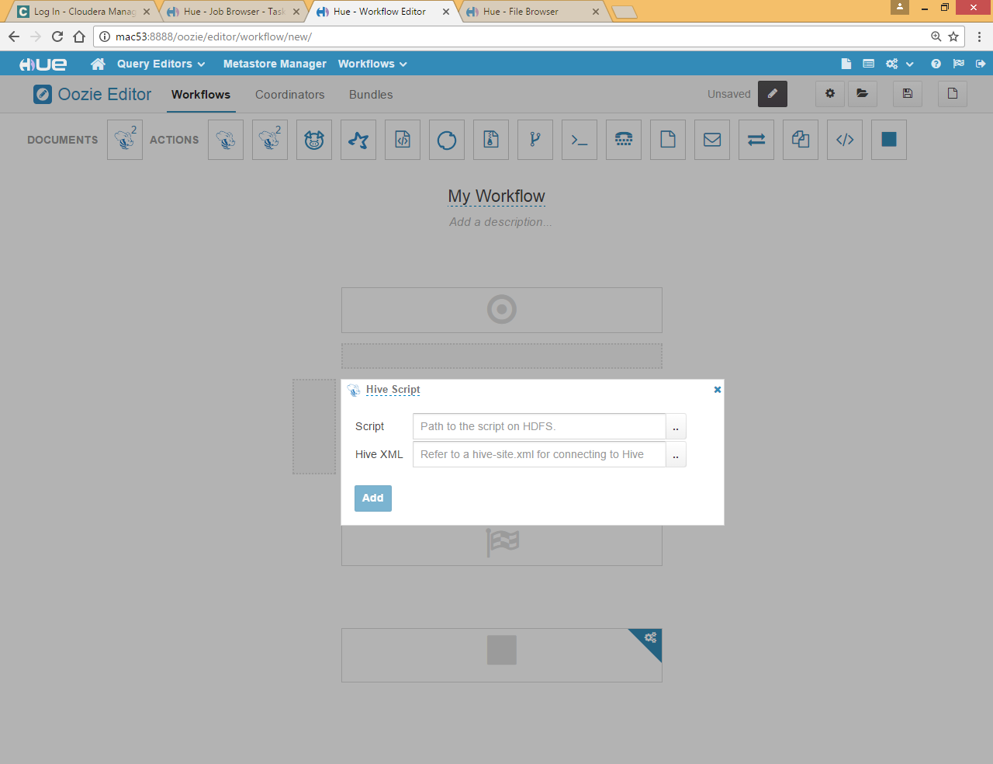

Specify script and hive xml path , you need to upload these files if not present in hdfs



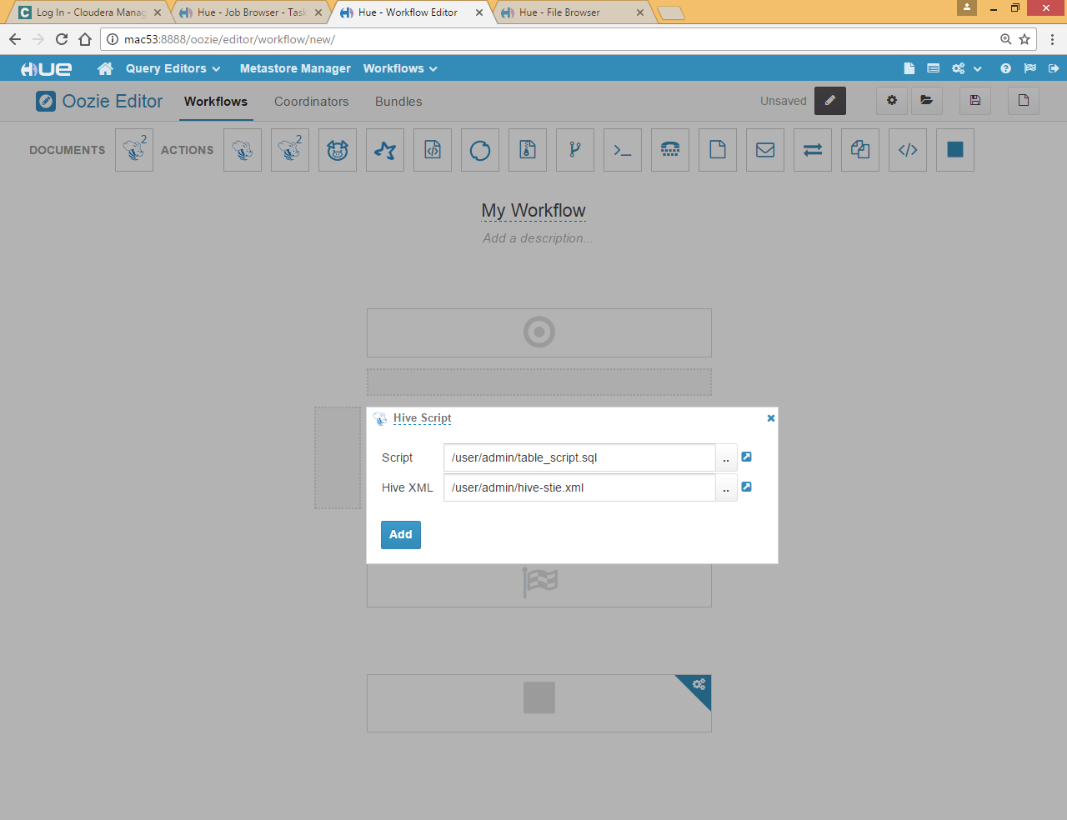

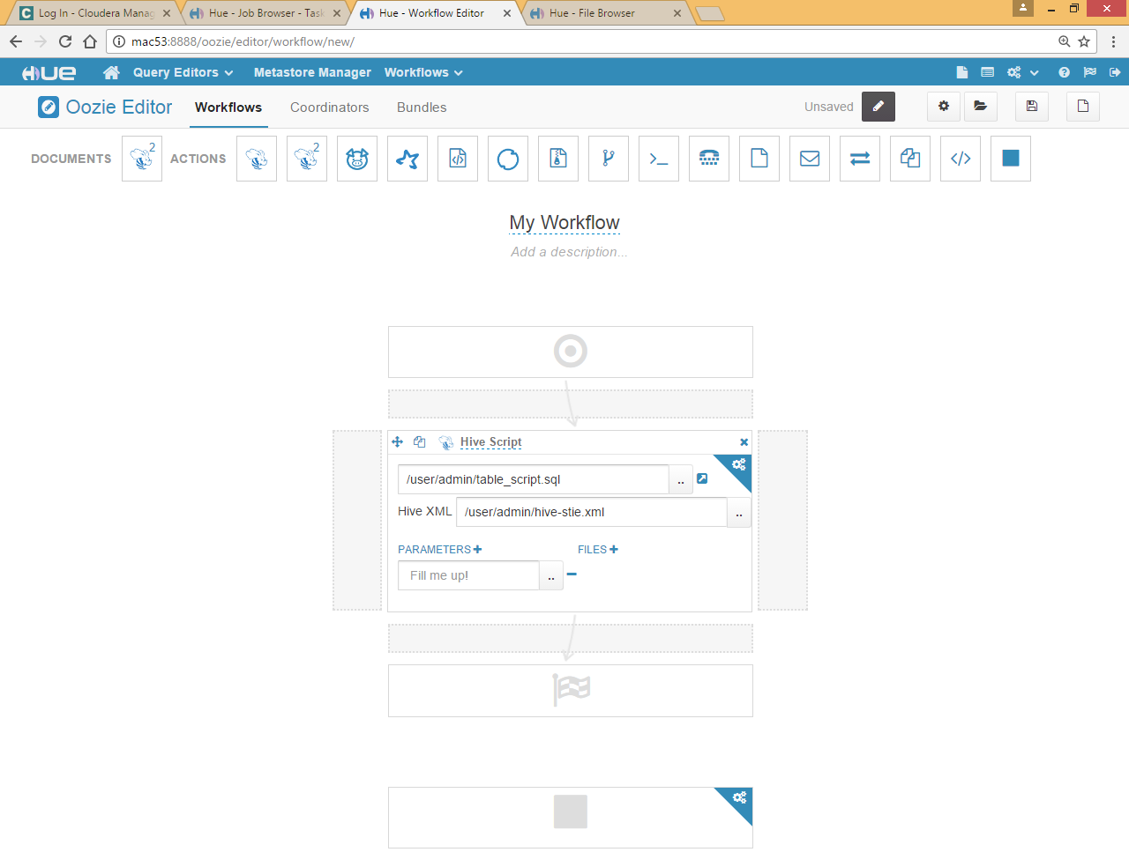

Add parameter

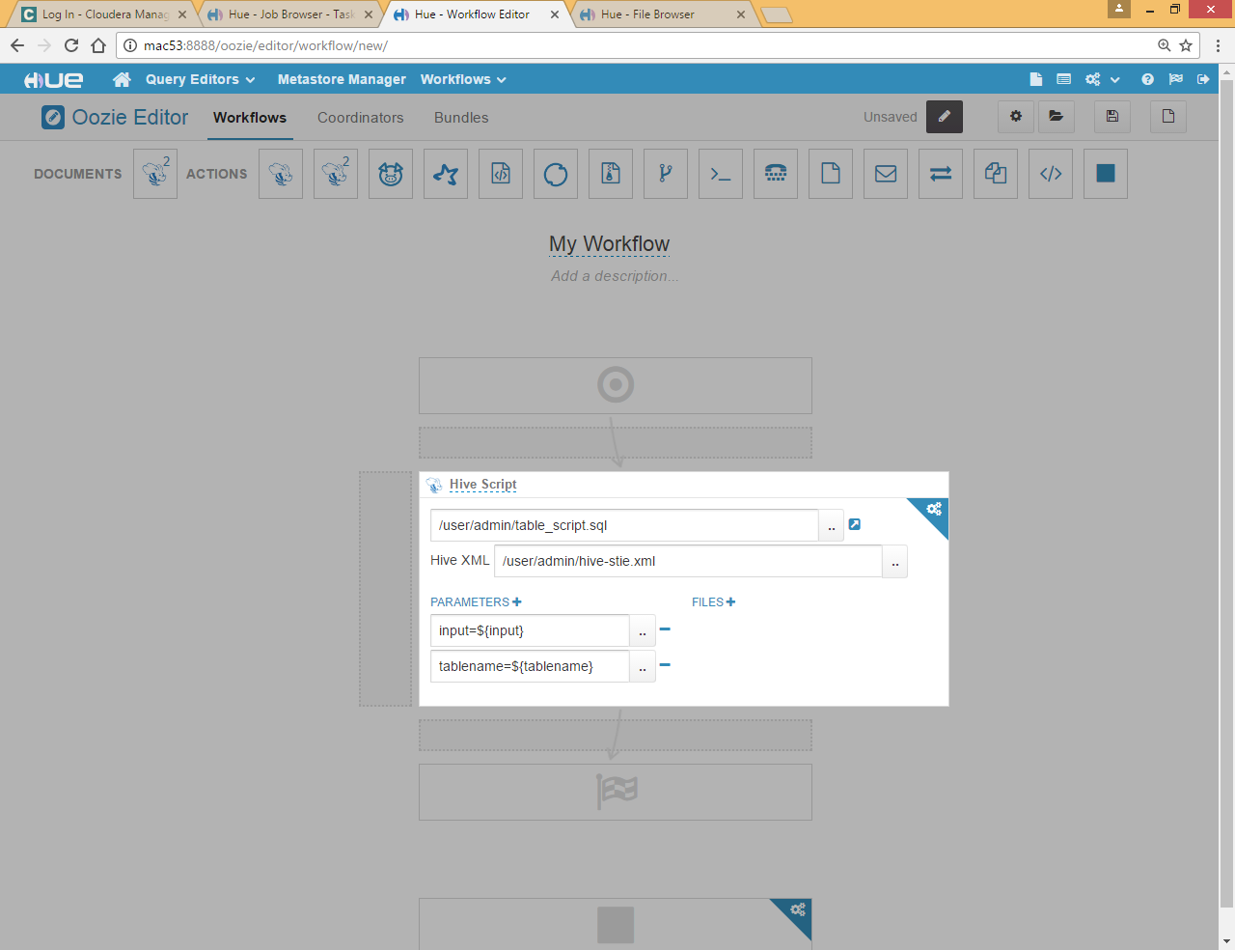

Click on Save

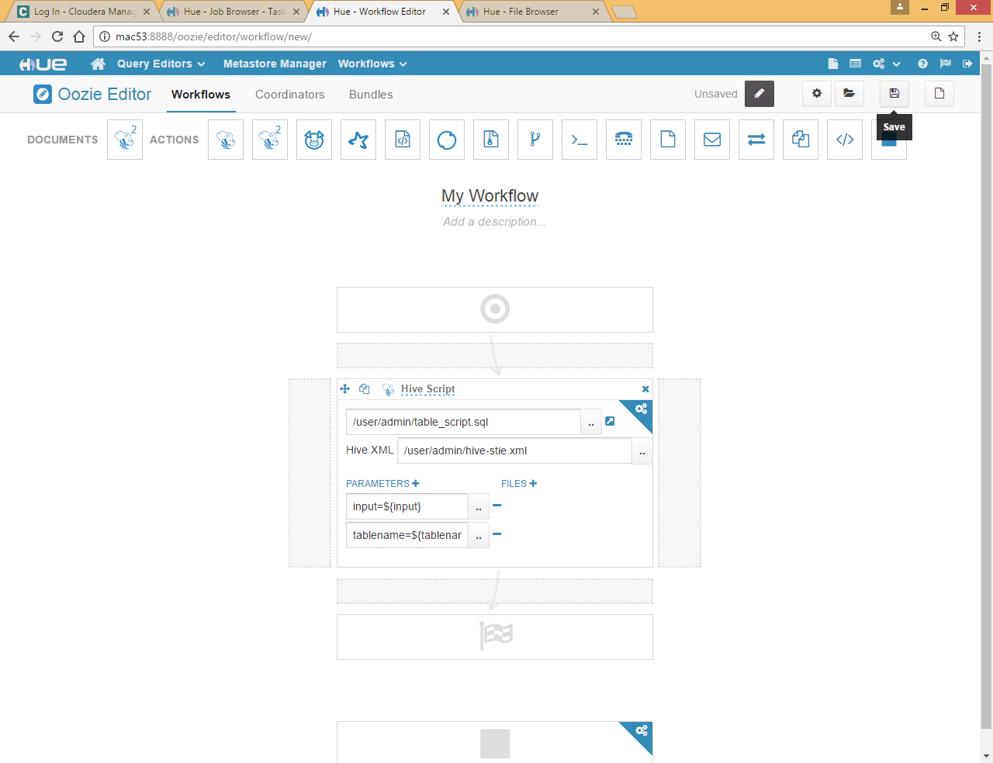

Click on Submit

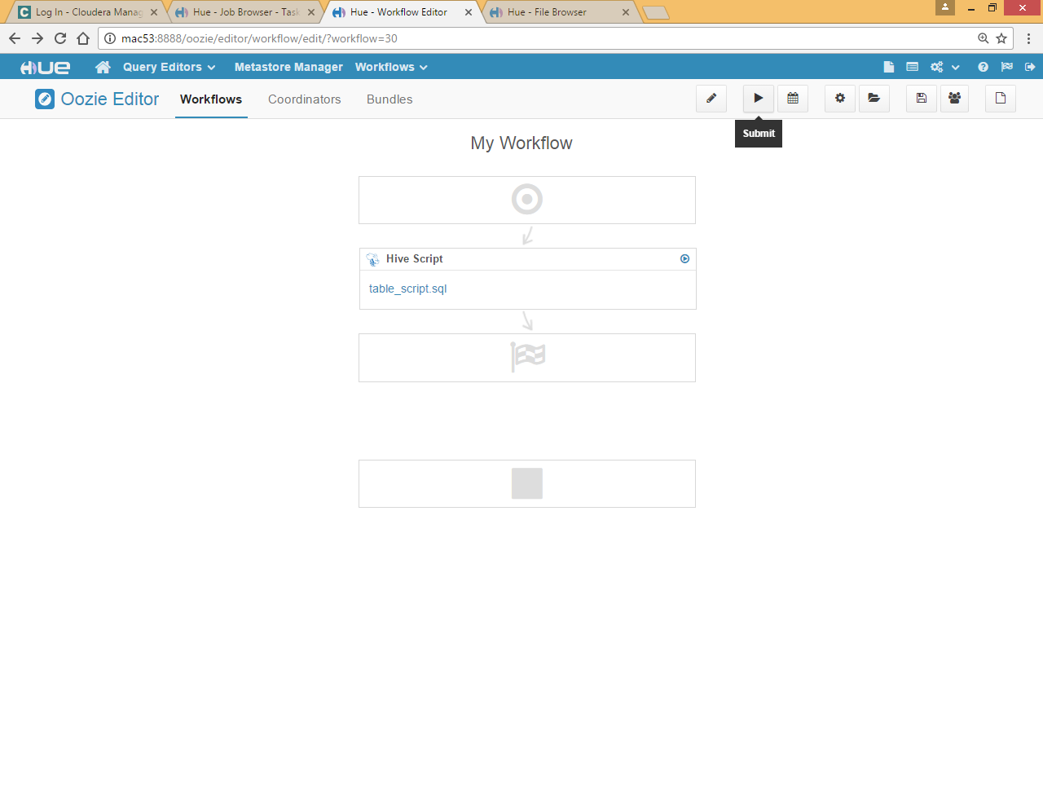

Give input file path and table name

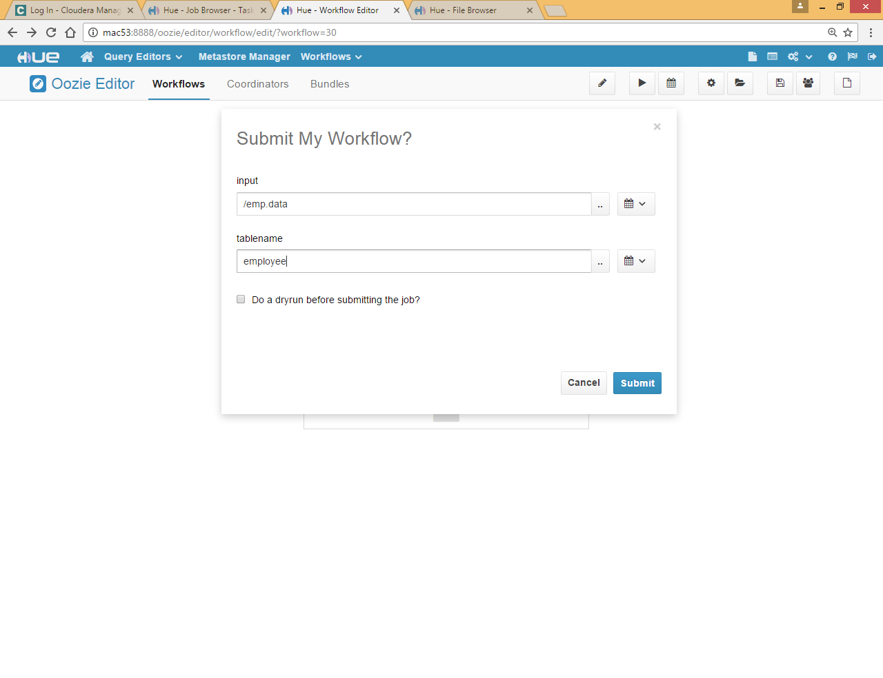

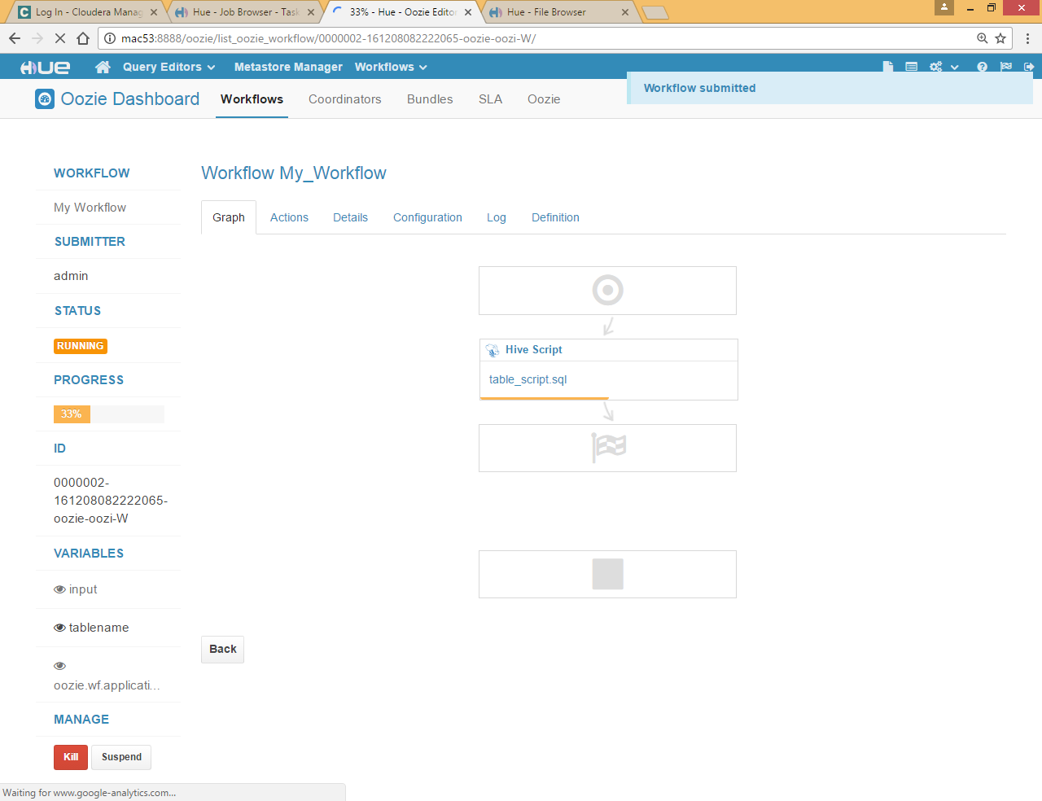

Go to hive shell and check if employee table created successfully

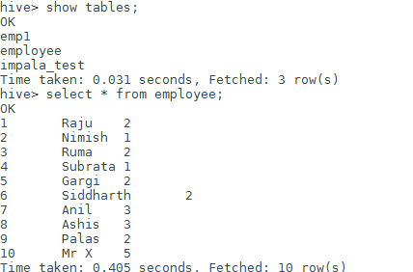

# Oozie workflow for shell script

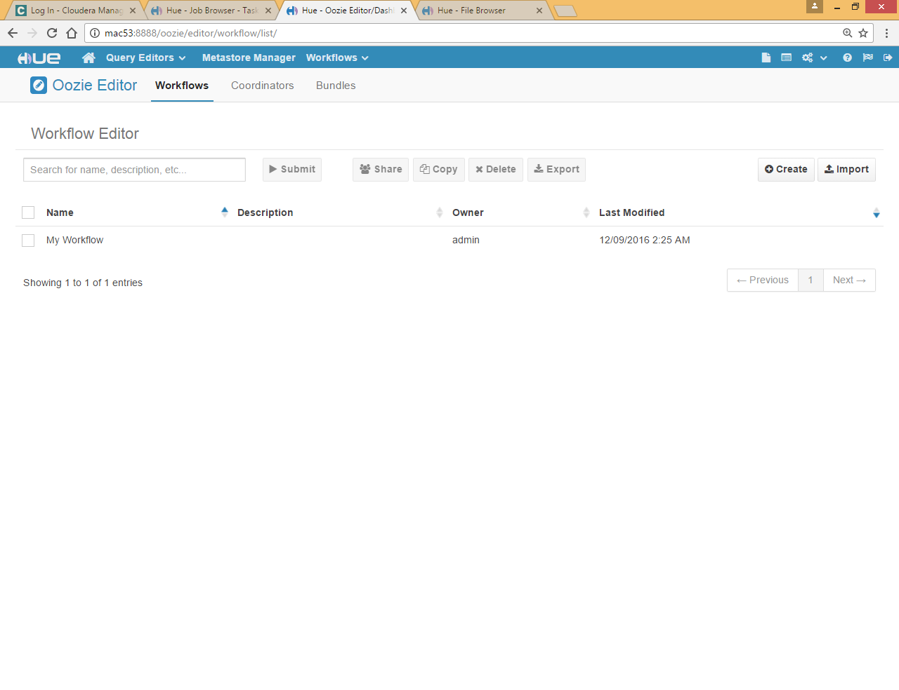

Create

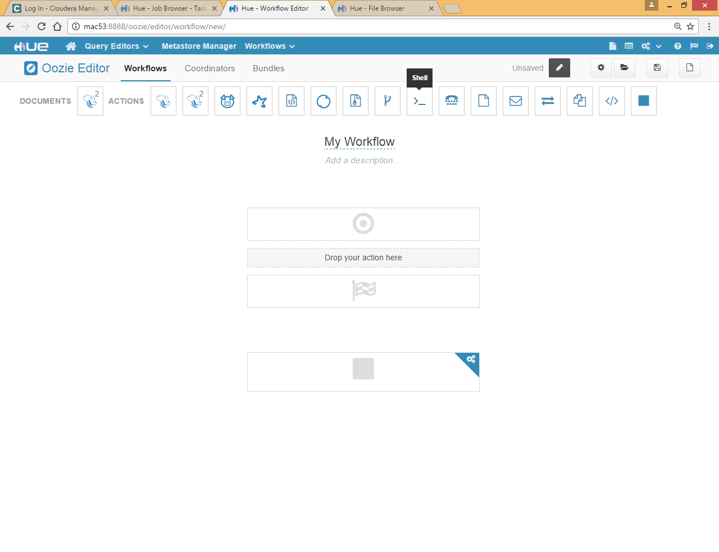

Drag shell

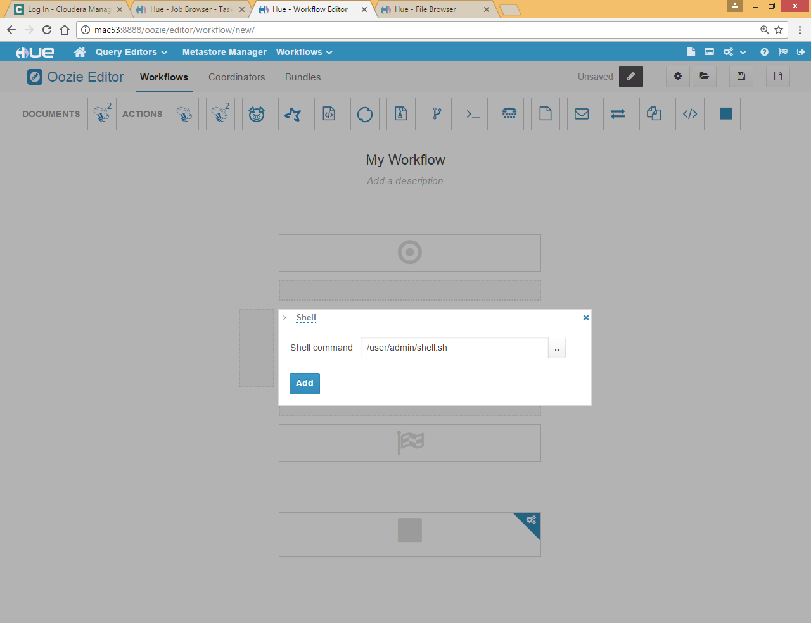

Choose below shell file



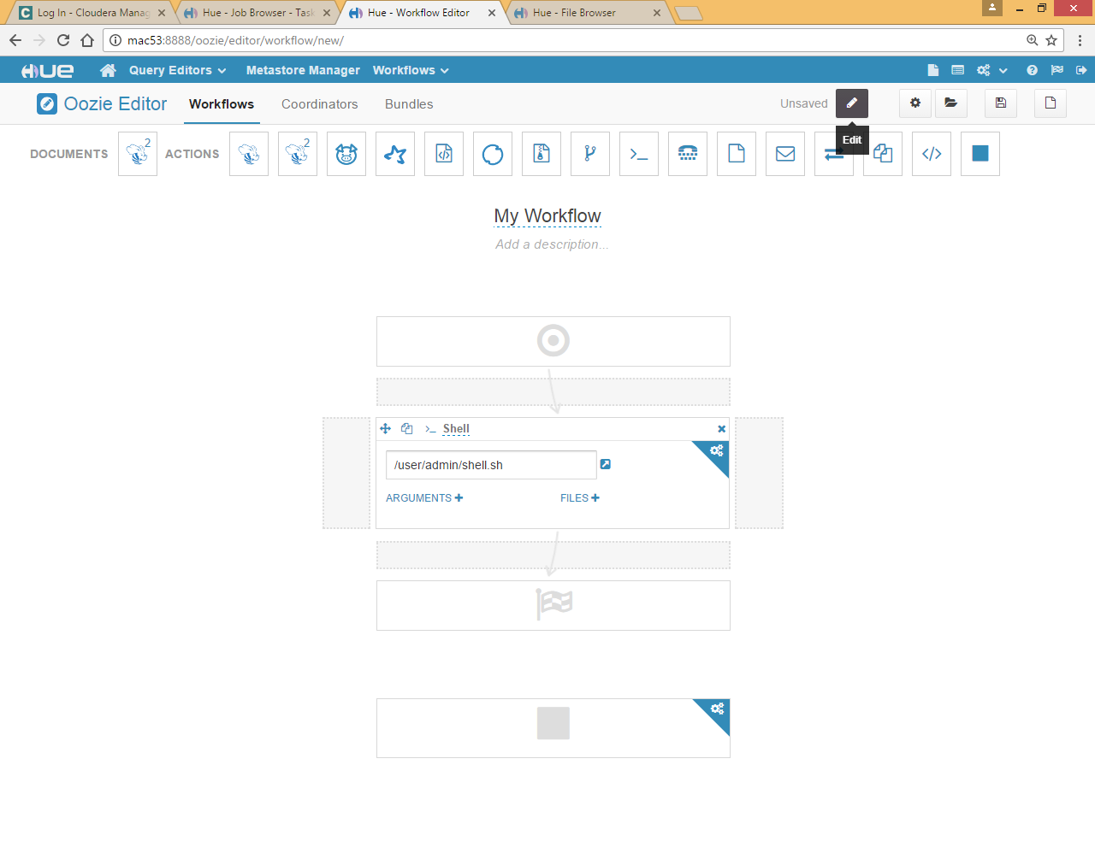

Click save and submit

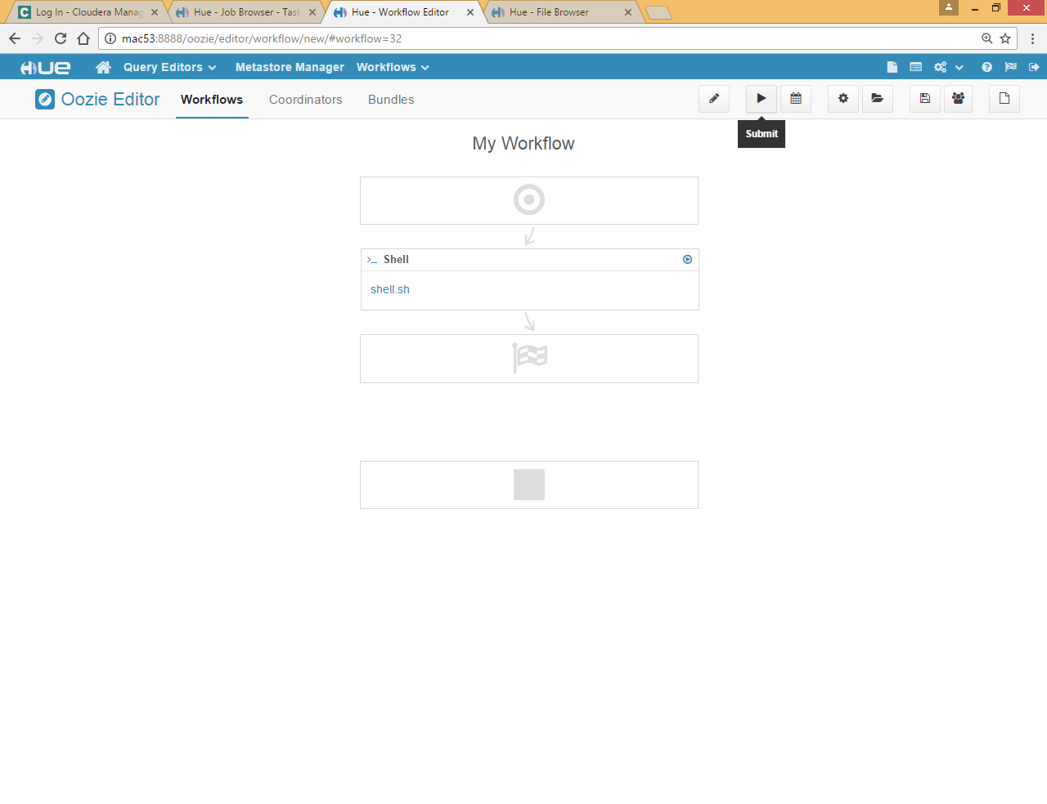

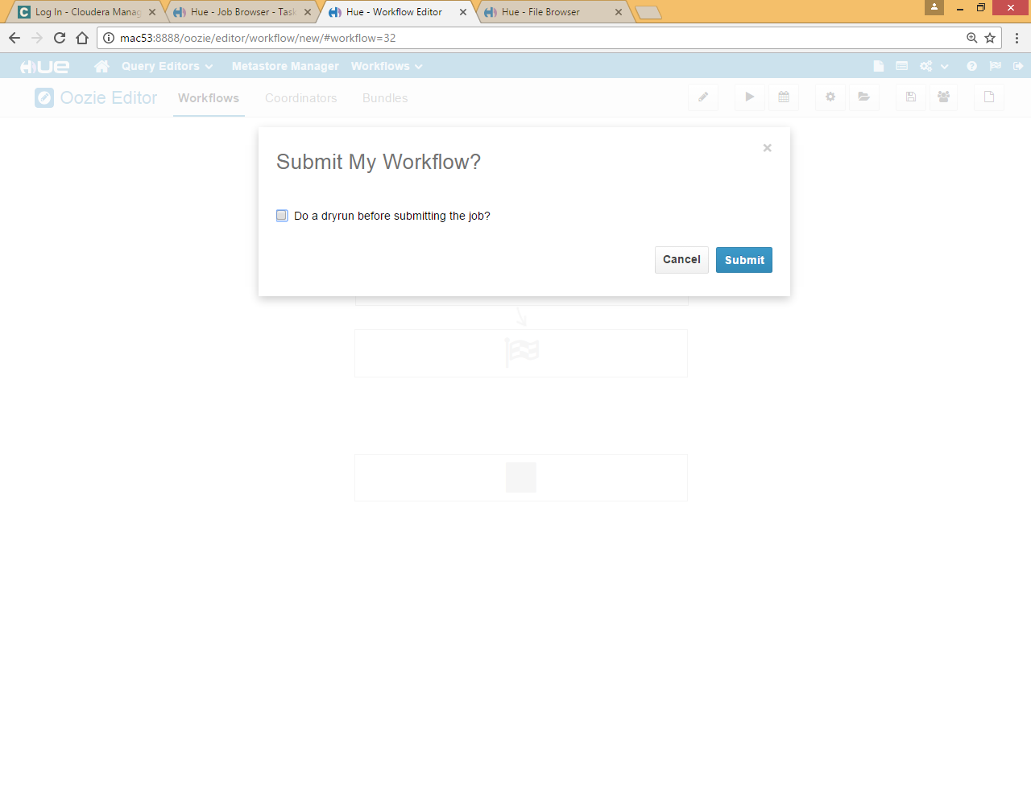

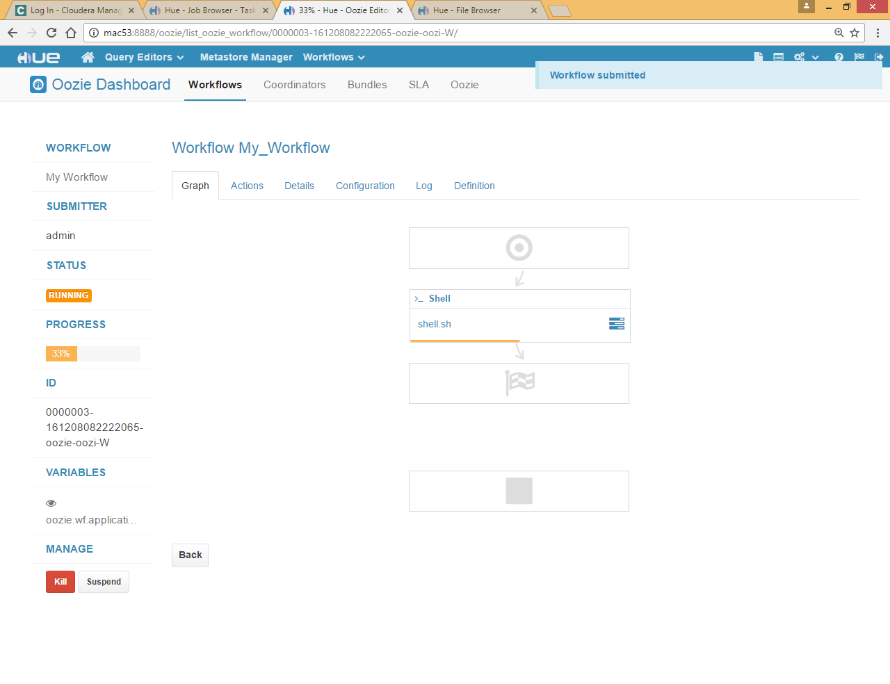

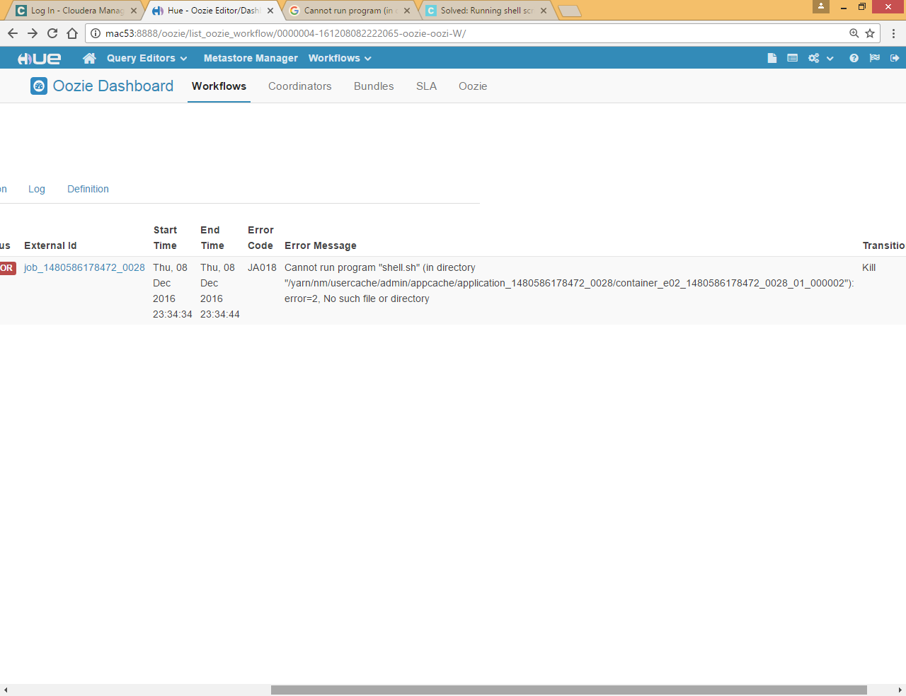

To resolve this issue we need to specify shell script file at two places **_shell and Files ,** see below screen shot

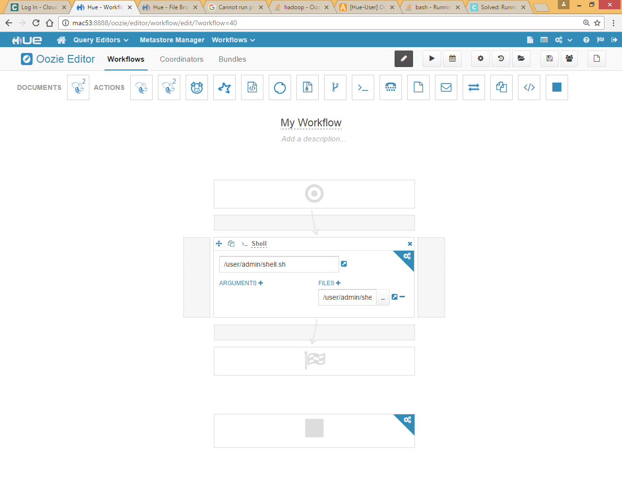

Now save it and submit it

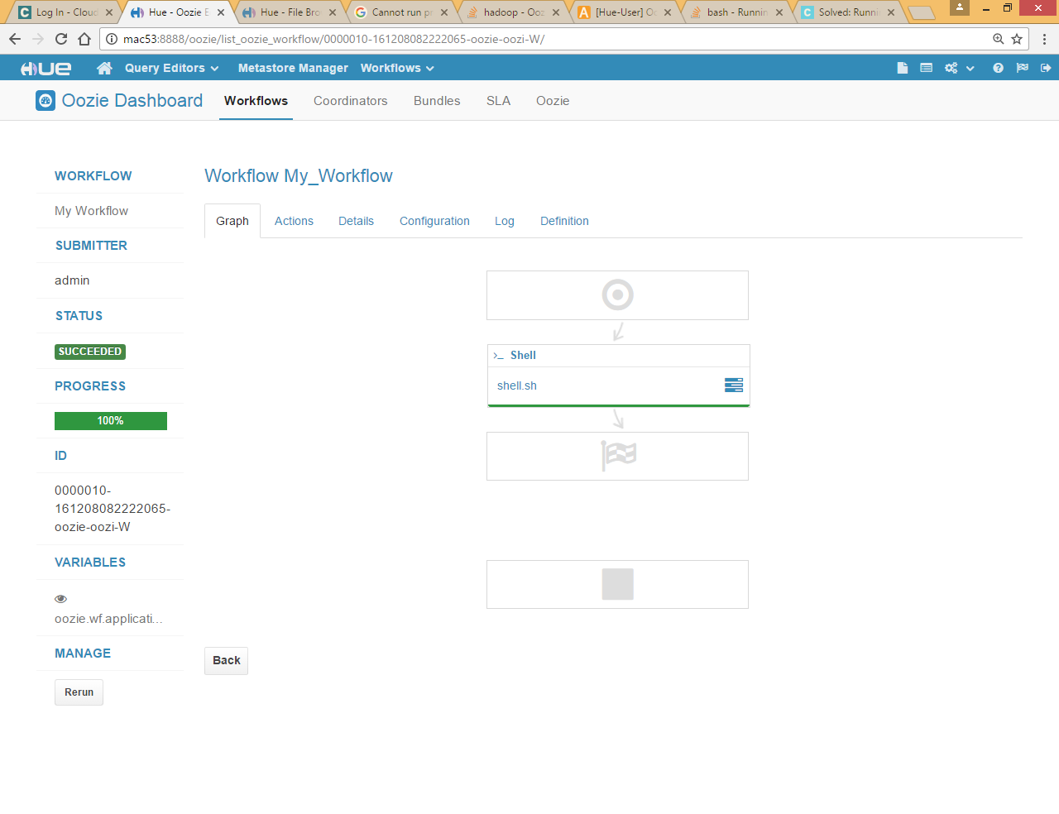

Though script ran with exit code 0 but map red job fail

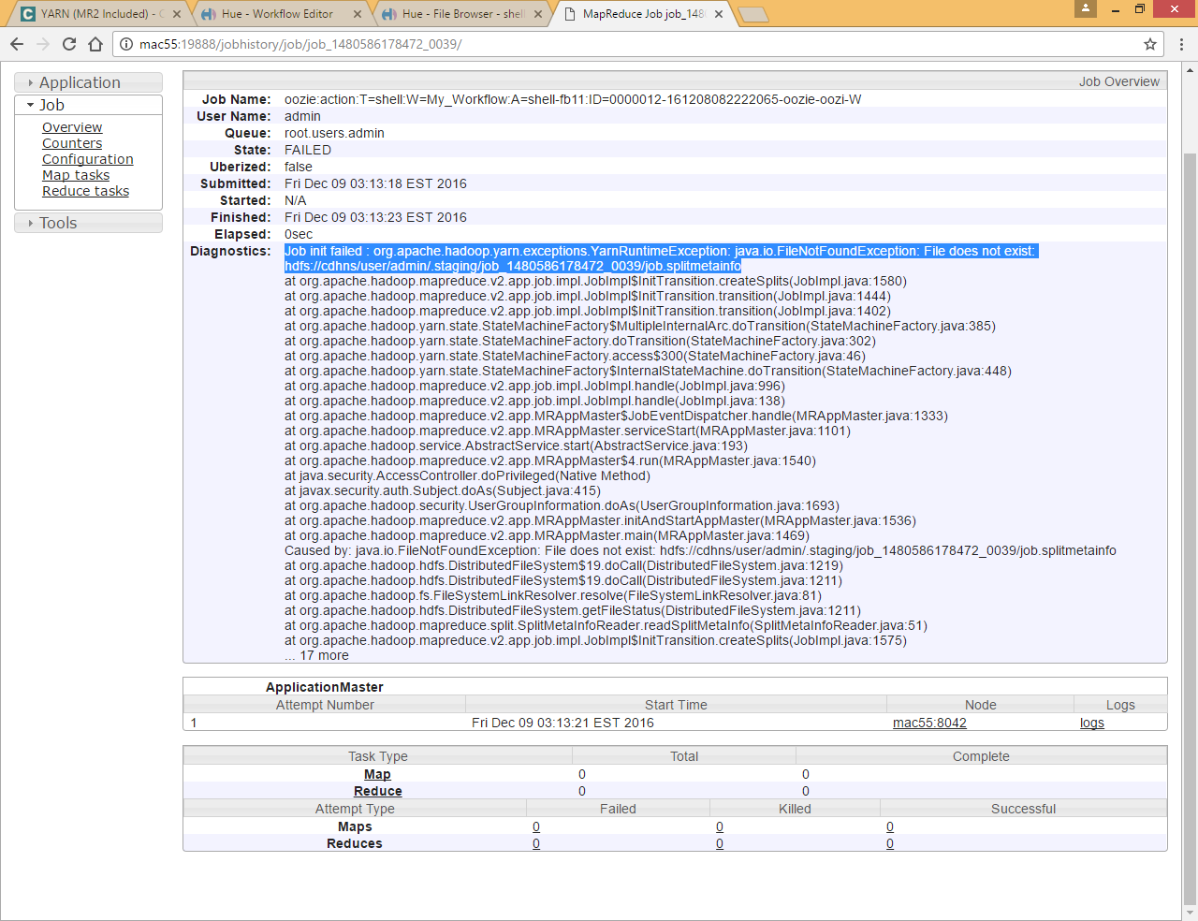

To solve this issue we need to create a yarn user in HUE

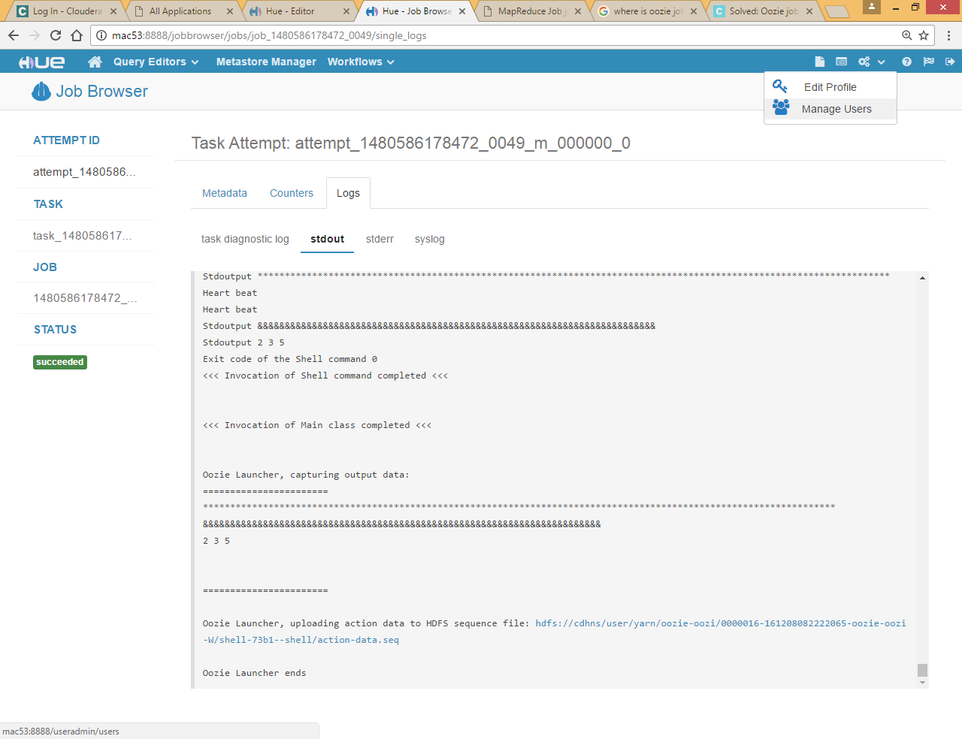

Click on manage users

And create yarn user

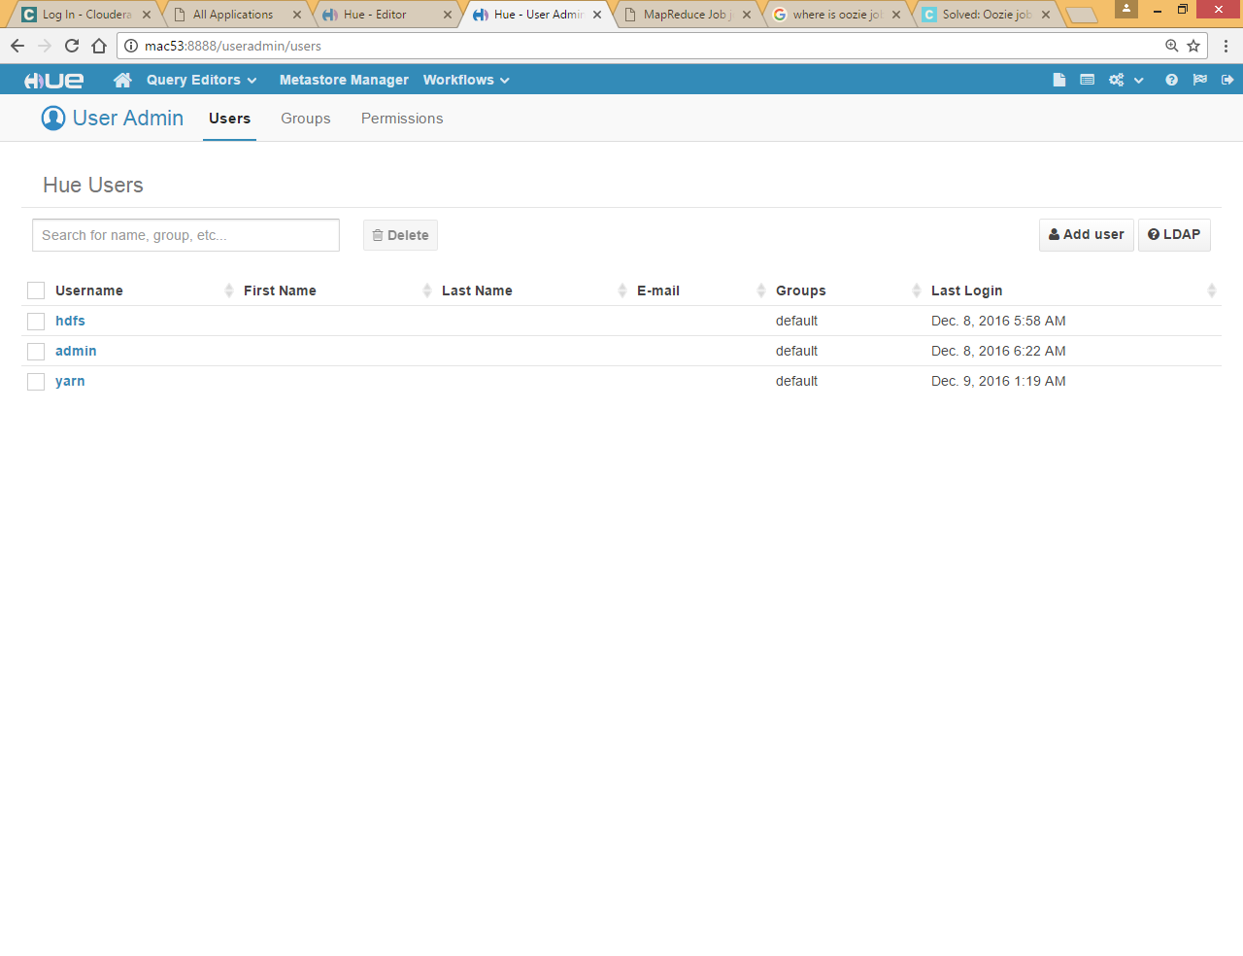

Now login with yarn user and run the workflow again it will successfully executed

To check the user name click on workflow>>Dashboard>>Workflow

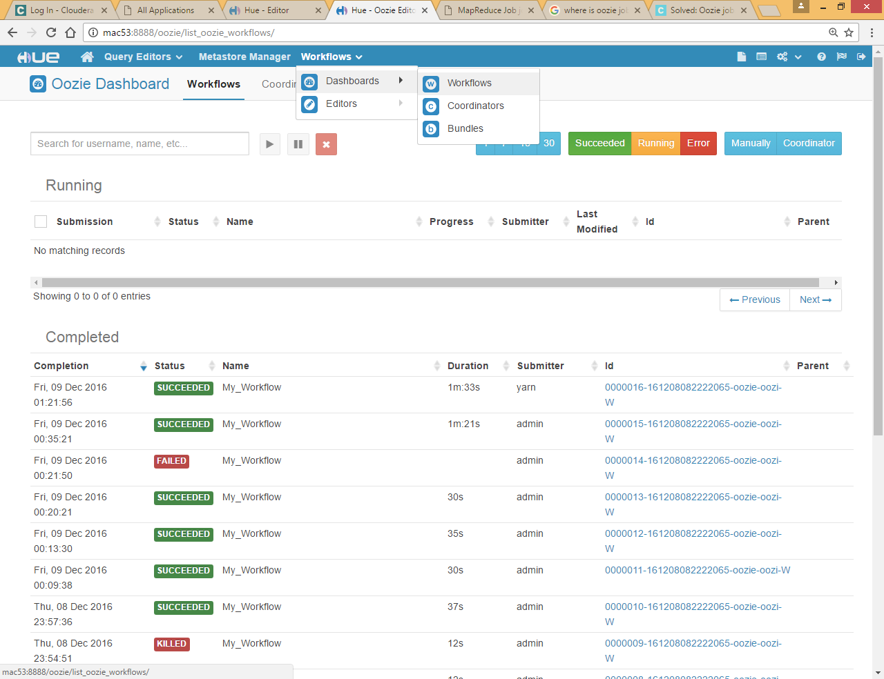

Now click on any link

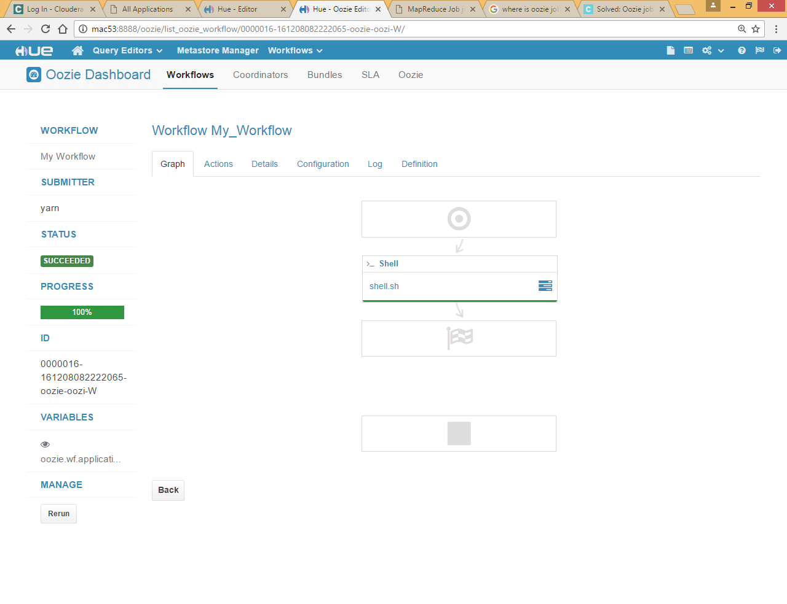

click on Configuration tab to see the configuration

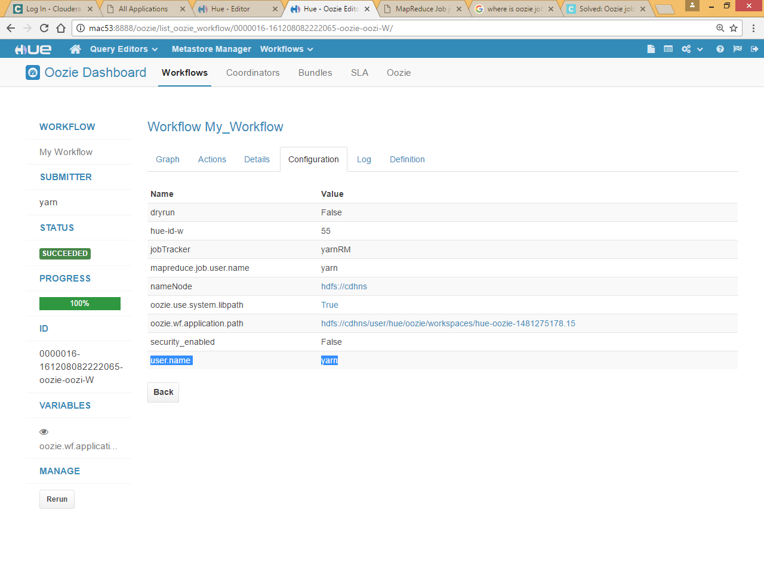

Here you can use that user.name is yarn earlier it was admin as we were login via admin user

# Oozie workflow for hive saved queries

Go to hive editor and save a query

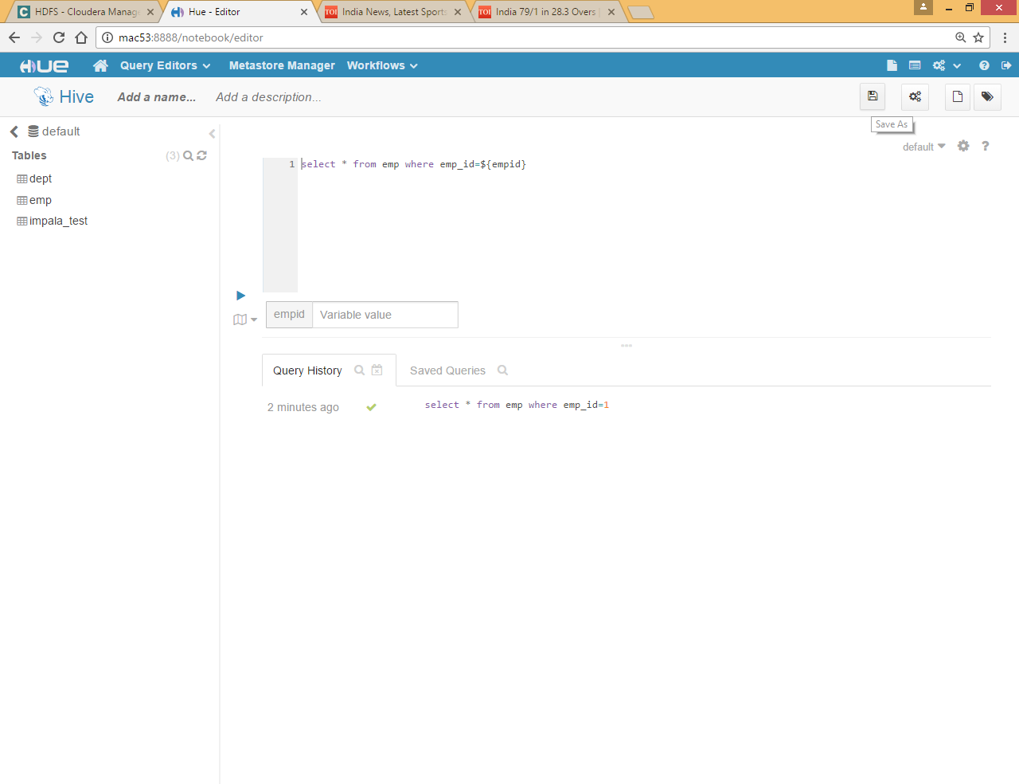

Give any name

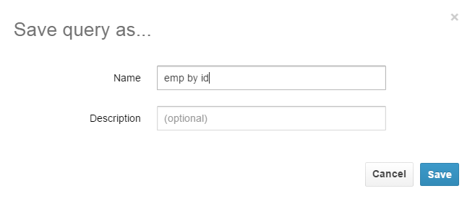

Now come to Oozie workflow and click create

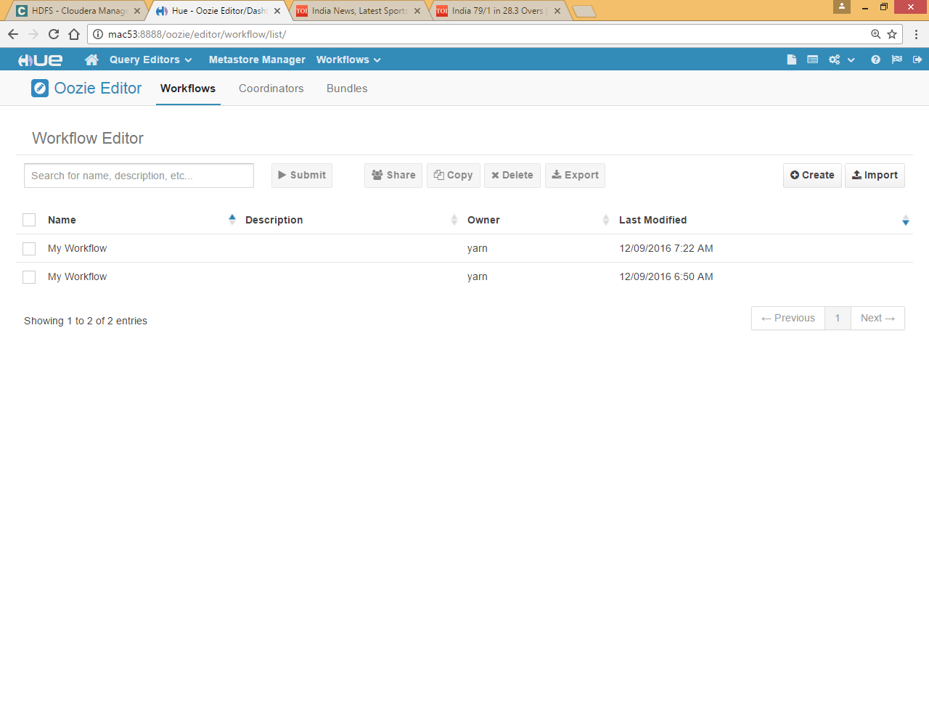

Drag drop saved hive query

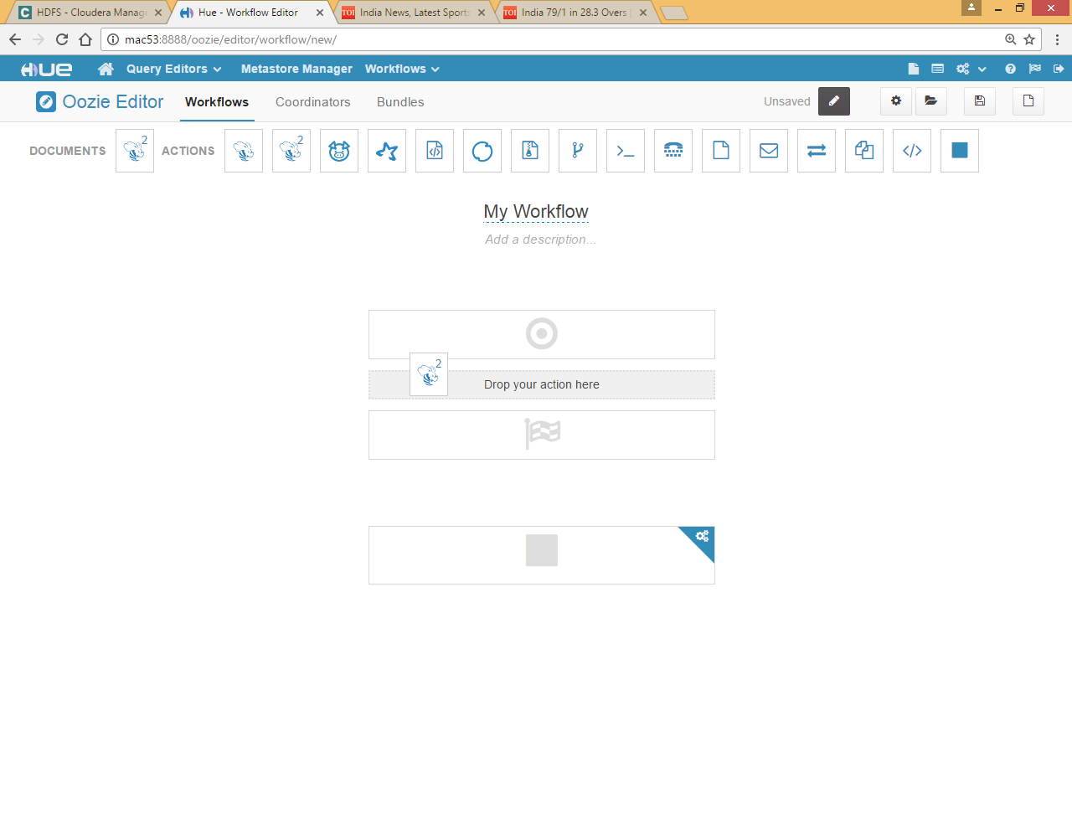

Choose save query

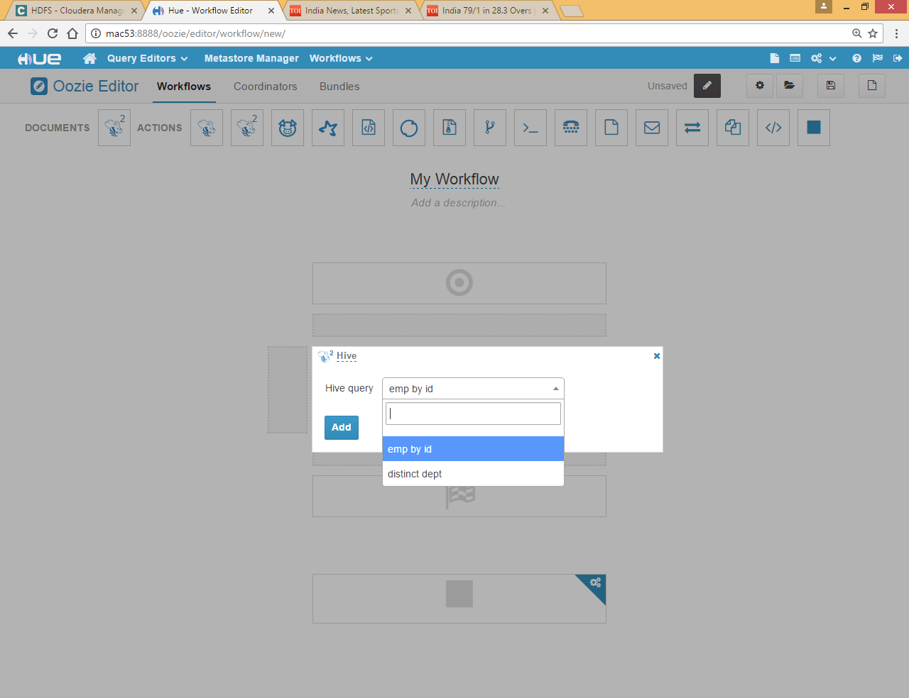

Select empid as empid is a variable there

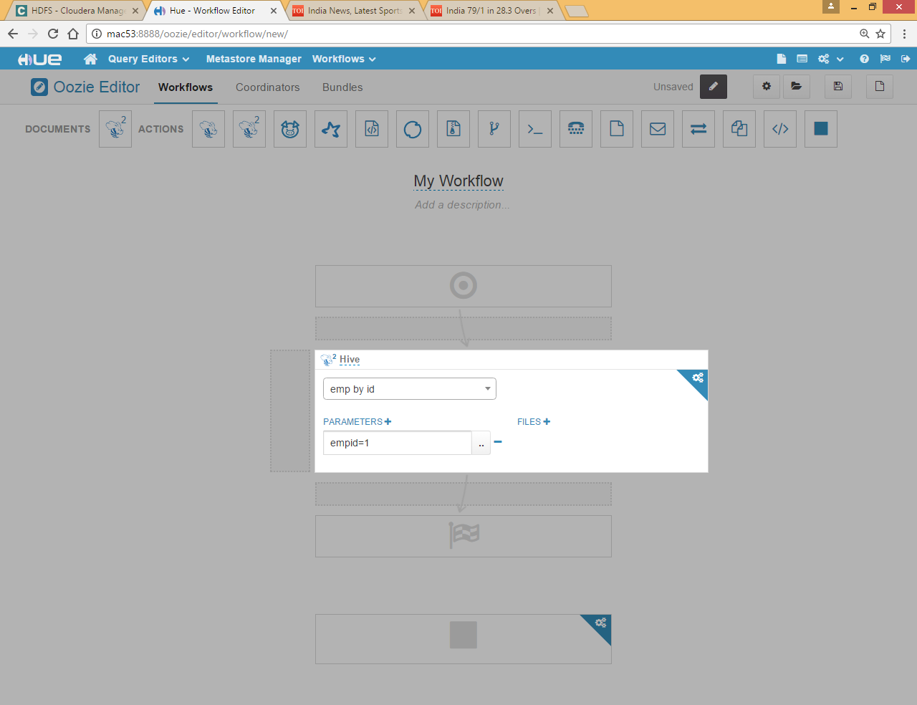

We can copy the same node

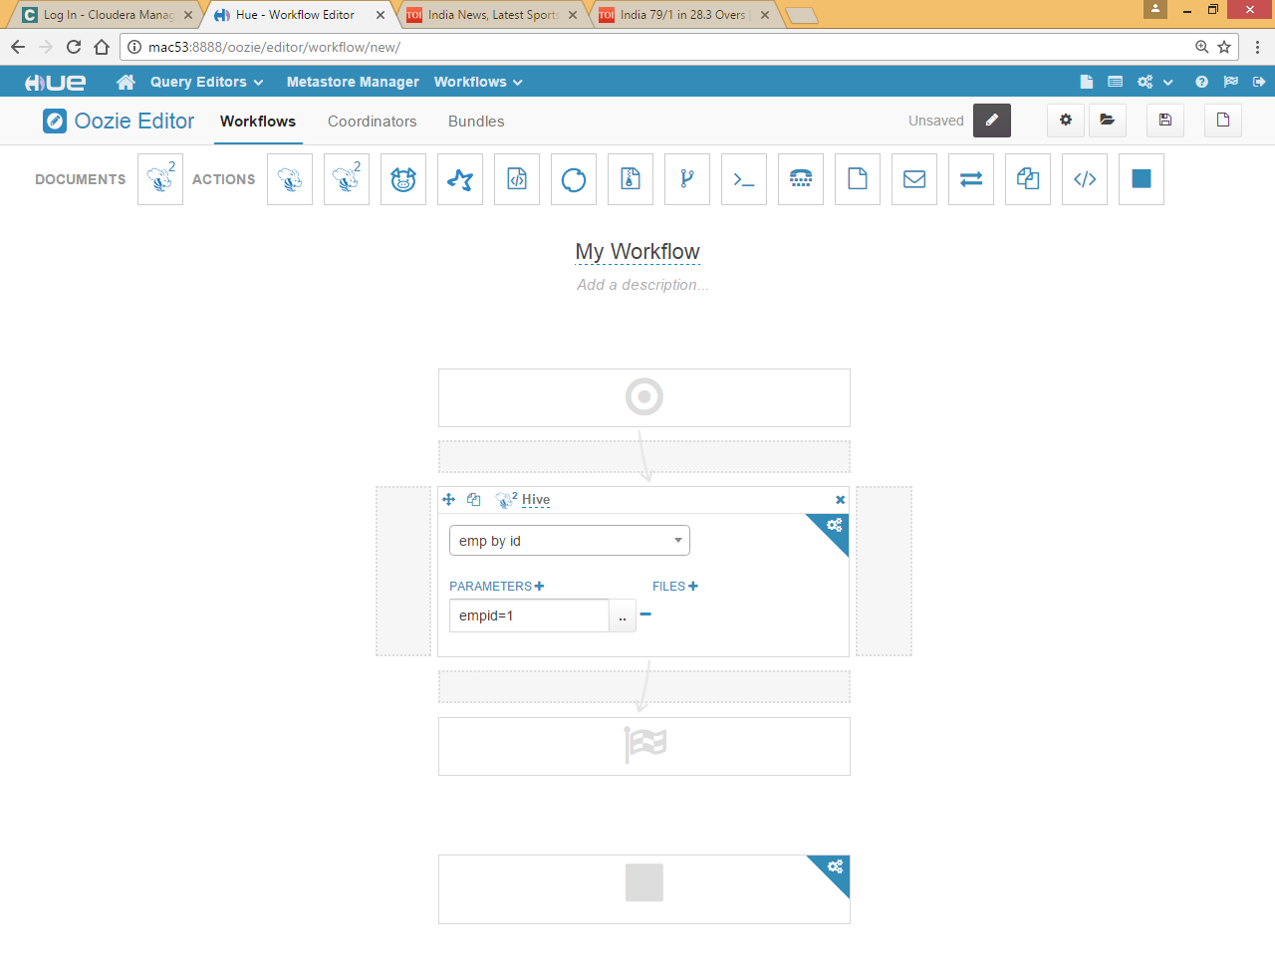

drag  icon and drop it to right box

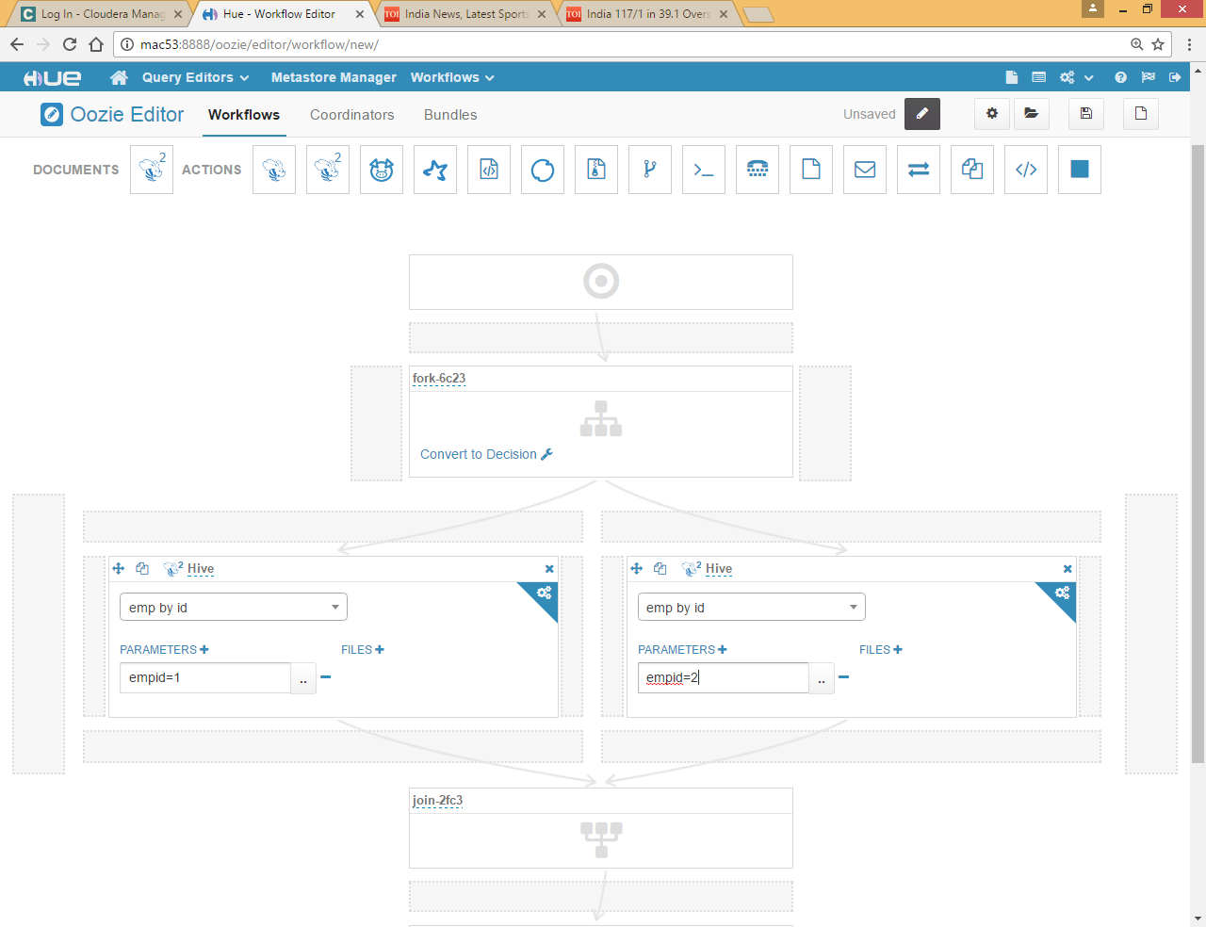

Give some different value of empid

Or you can also parameterized it instead of hard coding here

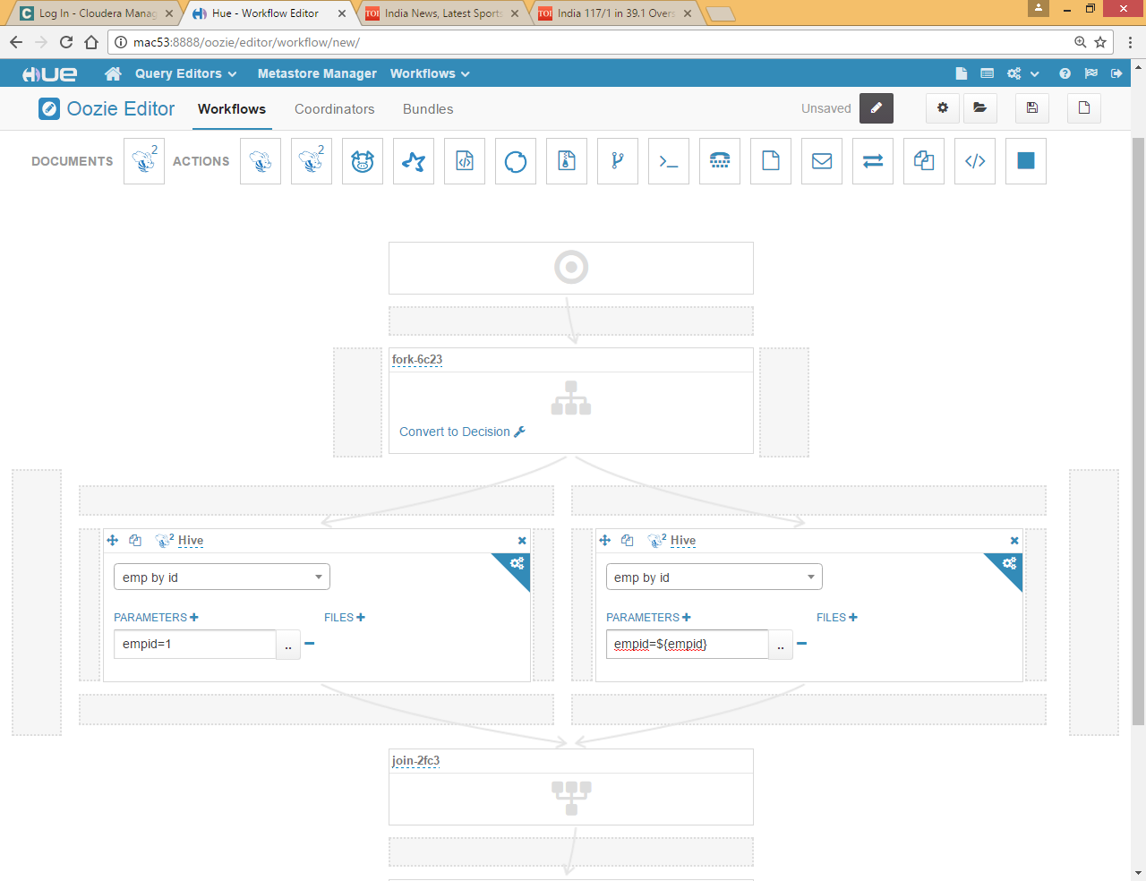

Save it and submit

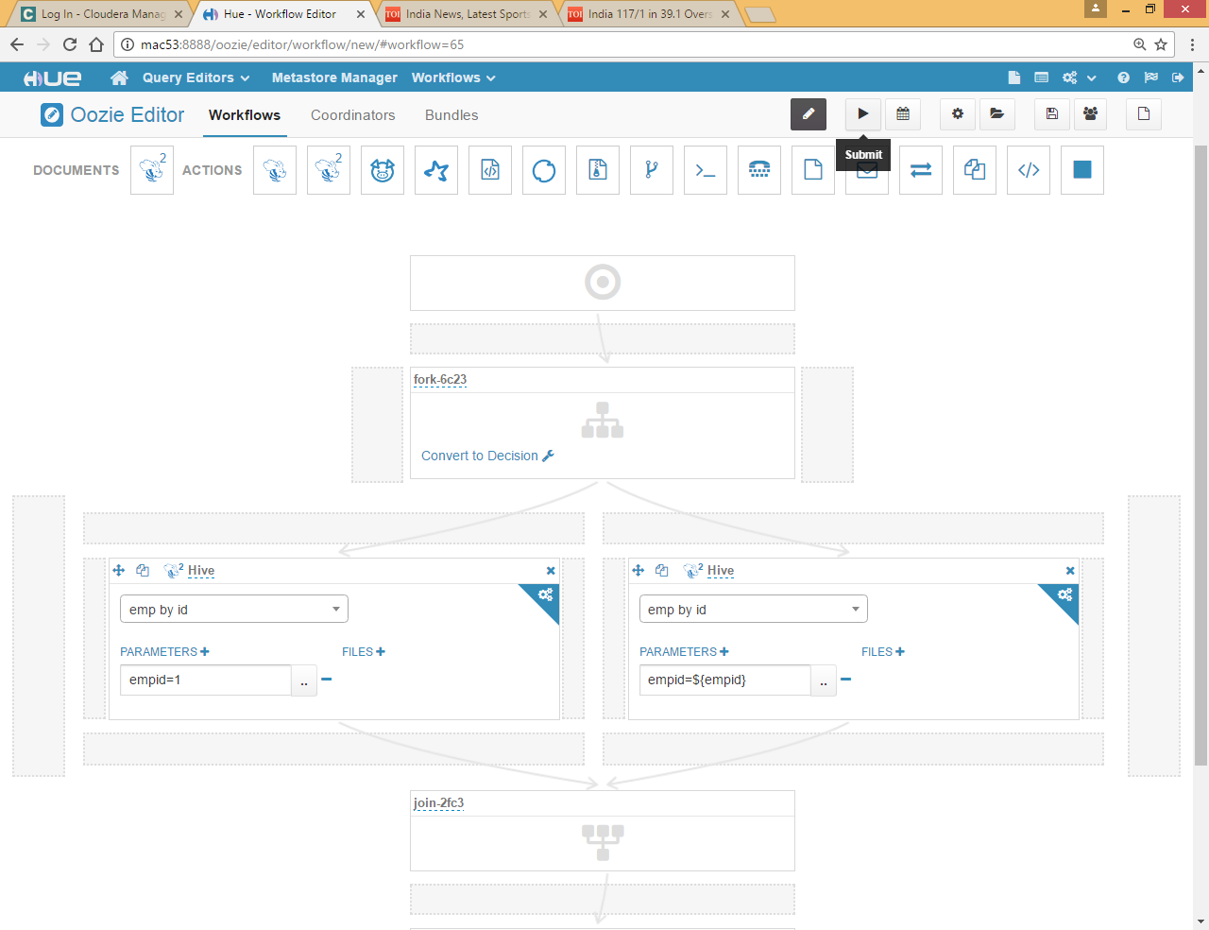

Here it will ask you for parameter

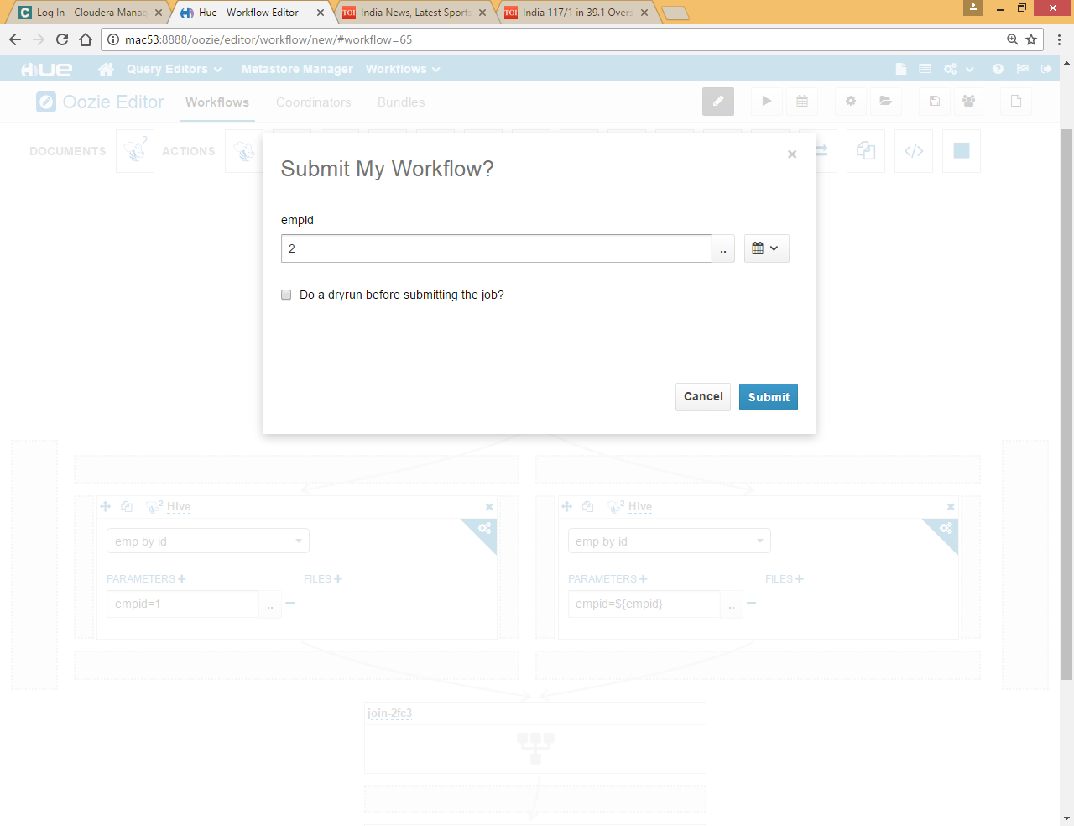

Click submit

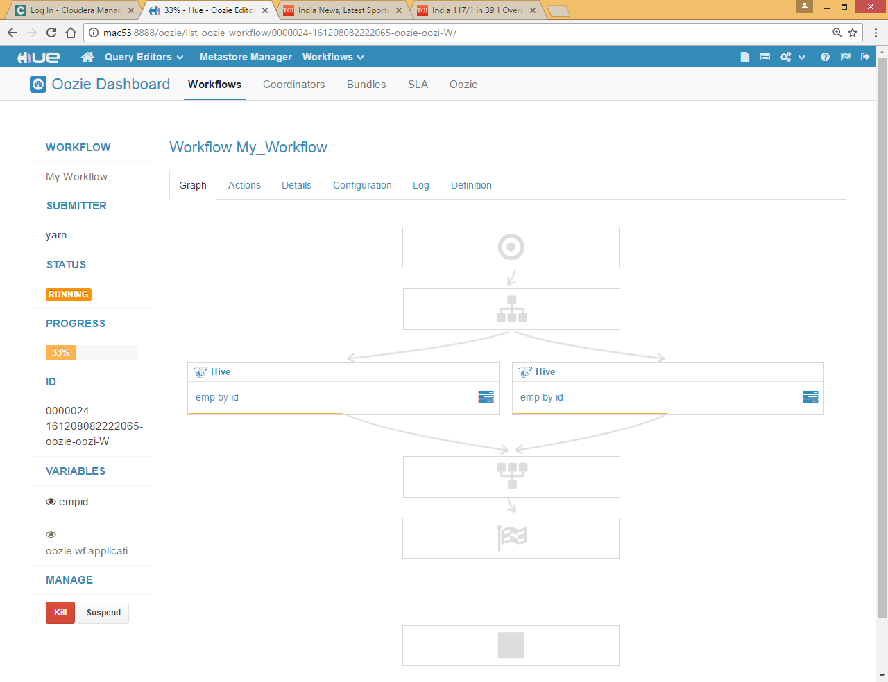

Both queries are running parallel

You can check Definition tab to generated xml

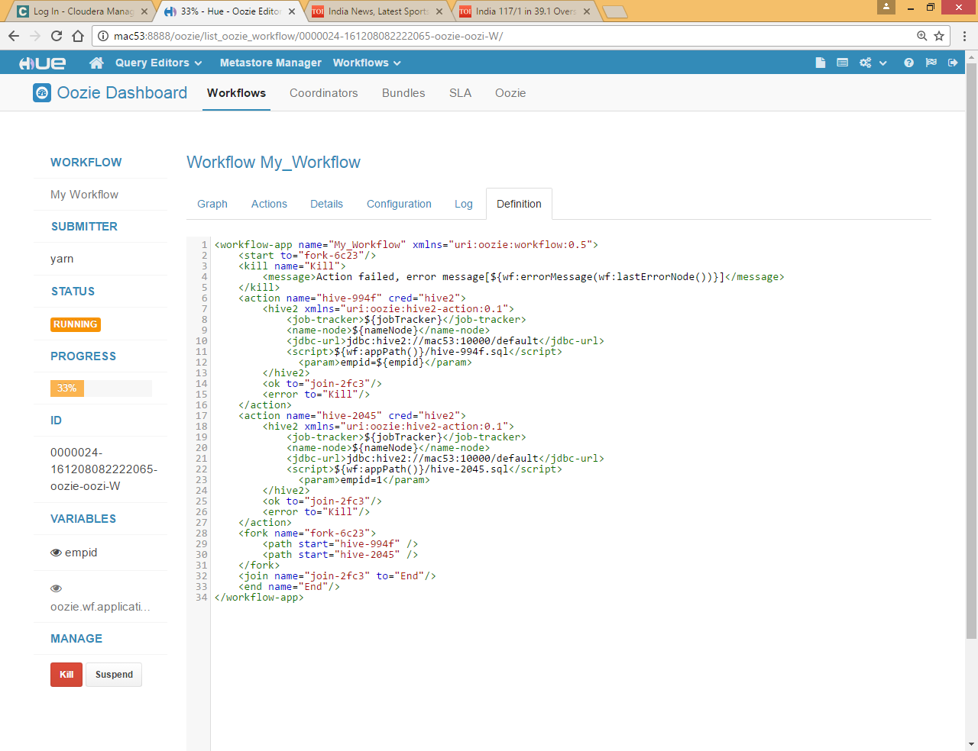

# Oozie workflow for java Action

Go to WorkFlow>>Editors>>Workflows and click on Create Button

Now just drag and drop java Program 

Now give the jar name and main class

If java class requires some arguments select it using arguments tag, in case of hcatlog java program for map reduce we need to select hive-site.xml file for this you can use Files tag to choose the file

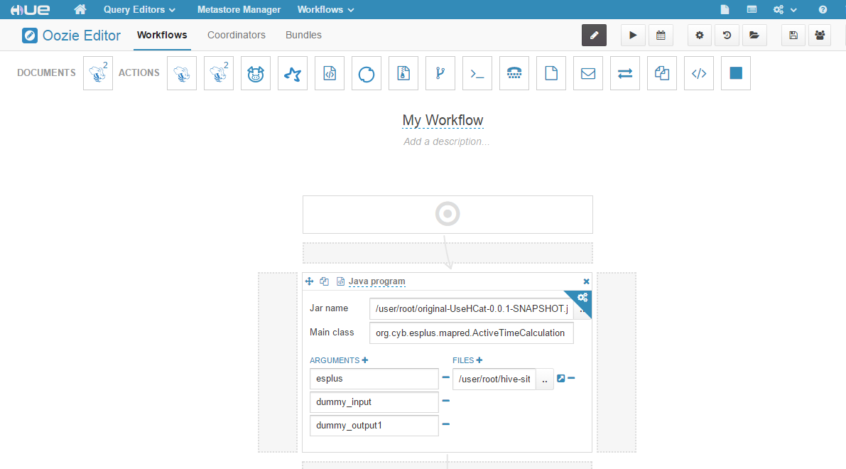

We can define third party jars in class path for that you need to click on jar name … button



Now in Achieve tag select individual jar files

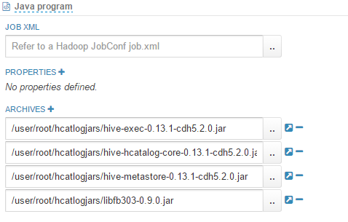

**Note : we need to include jar these jar files in lib folder under main application jar as well otherwise oozie throws class not found exception**

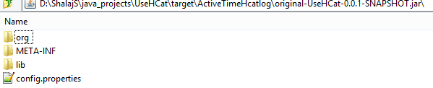

Now you can save and submit the workflow

By clicking on workspace button  you can jump to actual workspace

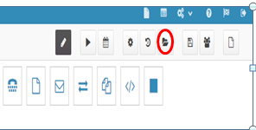

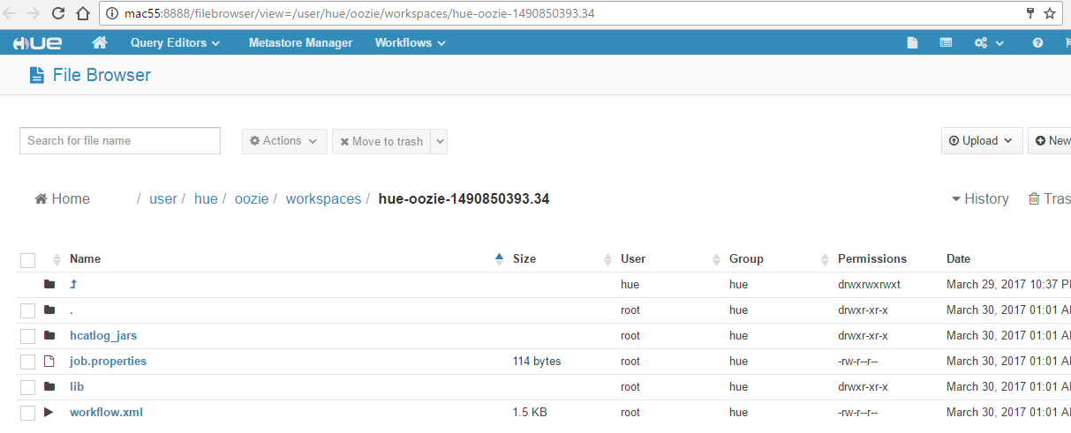

Here you will find lib folder that is folder where your main application jar will be uploaded

**Workflow.xml** contain actual workflow

**Job.properties** contains client side properties

Here **hcatlog_jars** is manually created, you can ignore this folder

# Oozie Coordinator

The Oozie Coordinator system allows the user to define and execute recurrent and interdependent workflow jobs

Define some workflow first and if you want to schedule this job we need to create coordinator

Go to Workflow >> Editors >> Coordinator

Click on Create button

Click choose a workflow and select workflow

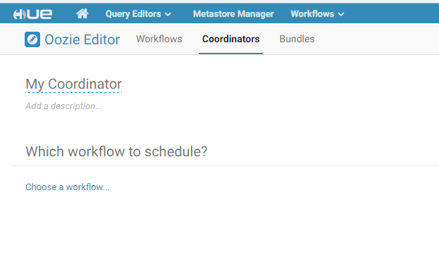

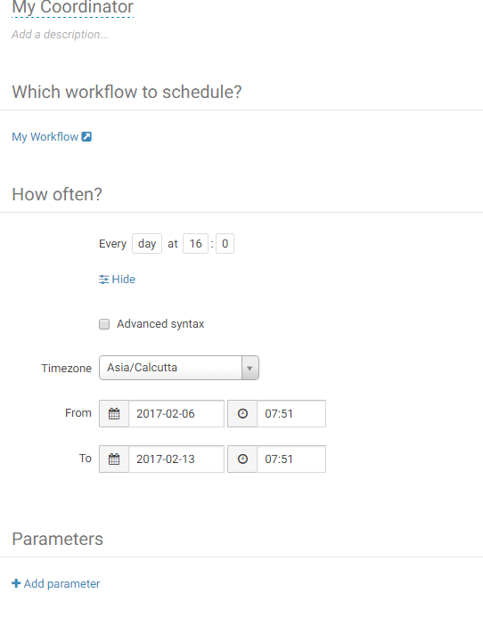

Now specify frequency from and to date to schedule this job, All datetime values are always in UTC so set it accordingly

If you have any parameters in workflow add it using Add parameter link save it and submit it

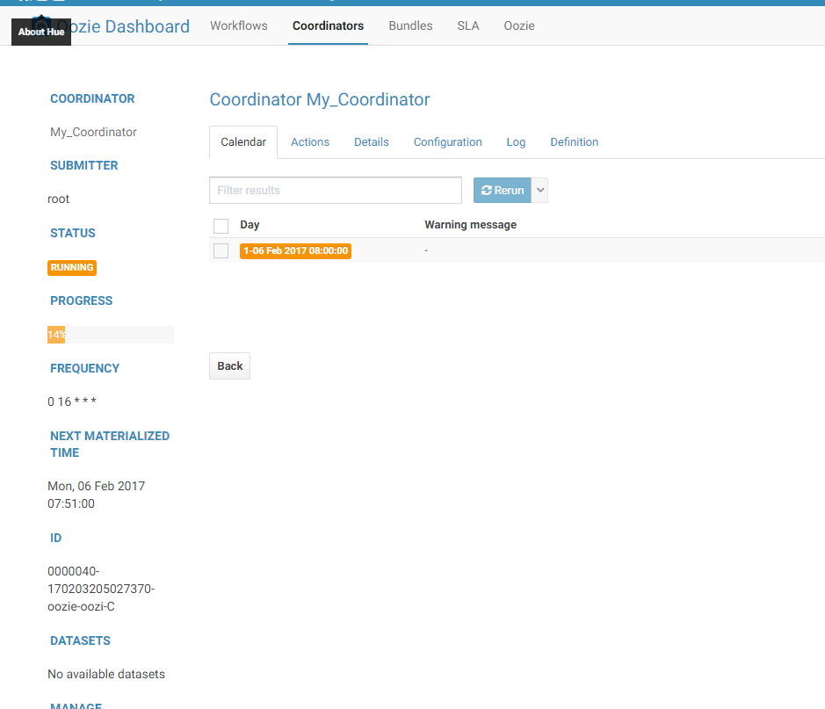

You can check the log in dashboard click Workflow >> Dashboard>>Coordinator



You can check the log from here